Chris Badalucco

Two Things LLC. | 2 first street, Albany ny 12203

Project Advisor: Professor John Avitabile degree advisor: dr. ian macdonald

Testing Results

Jalopy Exchange Project

Table of Contents

[2 Login 3](#_Toc405318728)

[3 Listing Filters 4](#_Toc405318729)

[4 User Specific Tasks 5](#_Toc405318731)

[4.1 Purchases 5](#_Toc405318732)

[4.2 Edit User Account Details 7](#_Toc405318733)

[4.3 Adding a New Automobile 11](#_Toc405318734)

[4.4 Deleting an Automobile 15](#_Toc405318735)

[4.5 Adding a New Listing 16](#_Toc405318736)

[4.6 User Closing Listing 21](#_Toc405318737)

[5 Admin Specific Tasks 23](#_Toc405318738)

[5.1 Listings Screen has admin specific abilities 23](#_Toc405318739)

[5.2 Manage users screen 25](#_Toc405318740)

# Login

Incorrect username/password will not be granted access

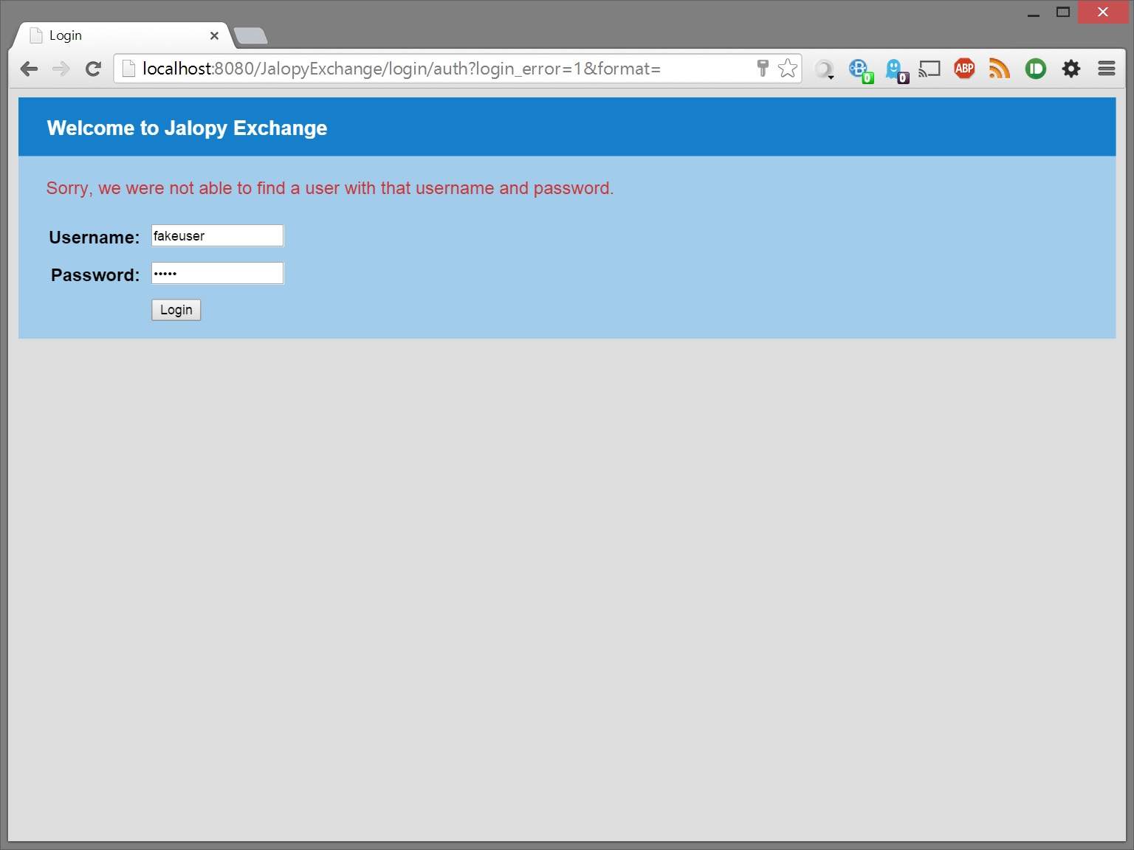

Users with a locked account will not be granted access

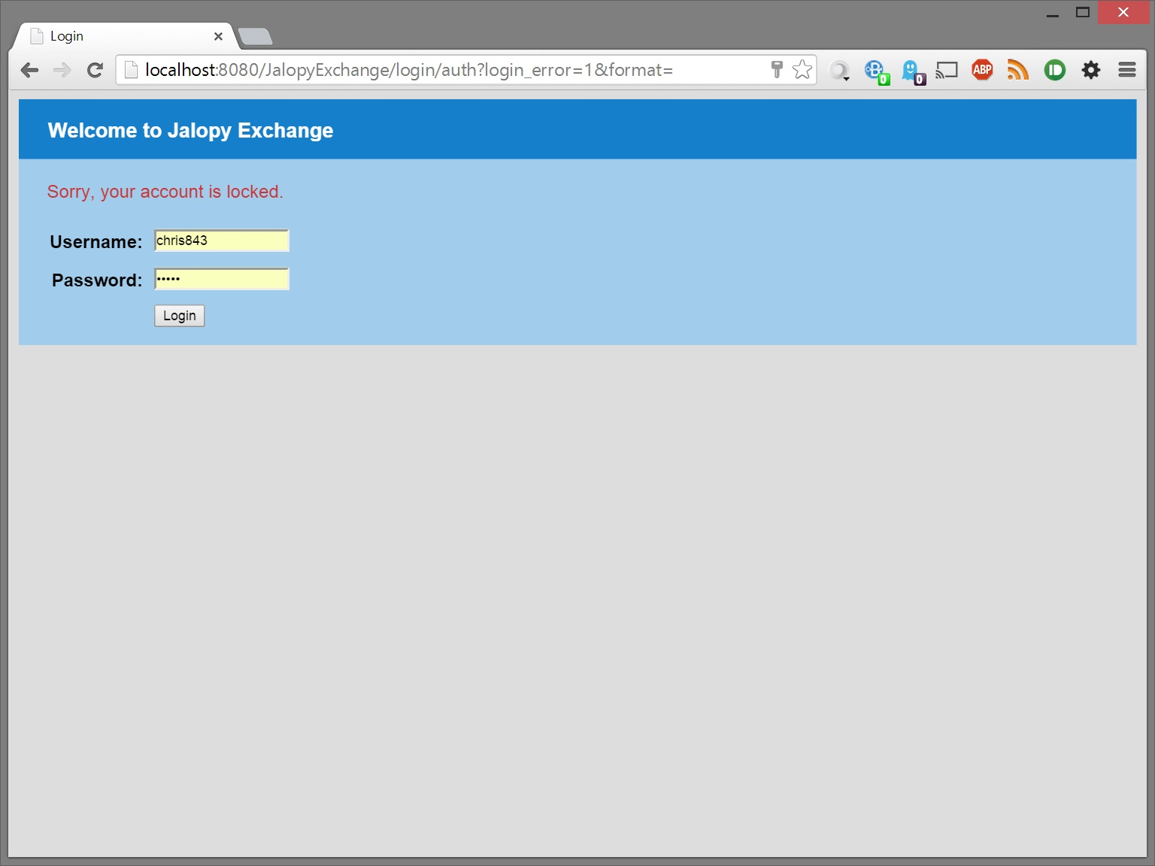

# Listing Filters

Status filters active or closed listings

# C:\Users\Chris\AppData\Local\Microsoft\Windows\INetCache\Content.Word\3_form_filter1.jpg

Make filters to the selected automobile make. Only automobiles in the system will have their make display in this drop down

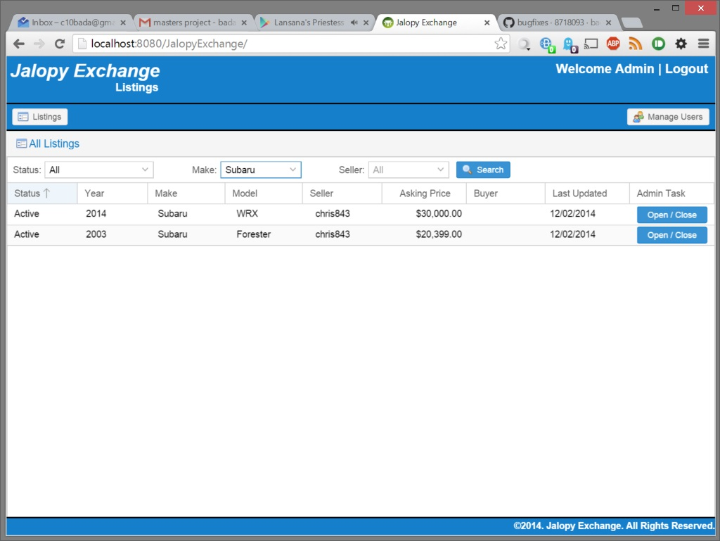

Seller filters to the selected Seller. Only users will listings in the system show up in the drop down

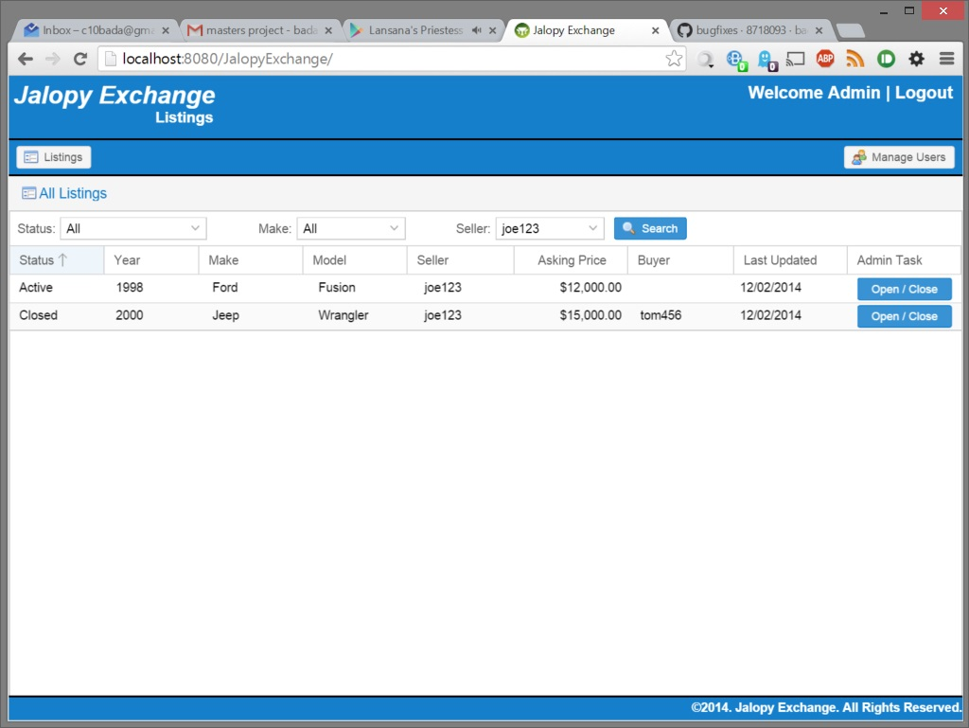

# User Specific Tasks

## Purchases

Tooltips display for the user

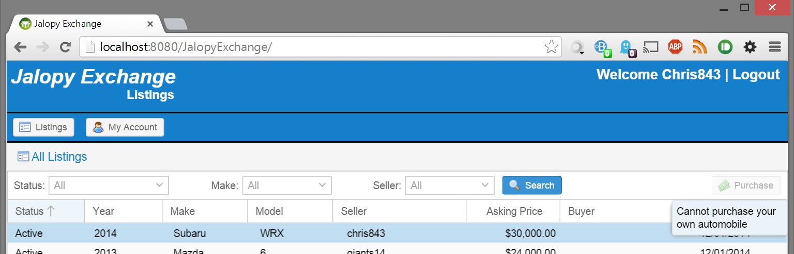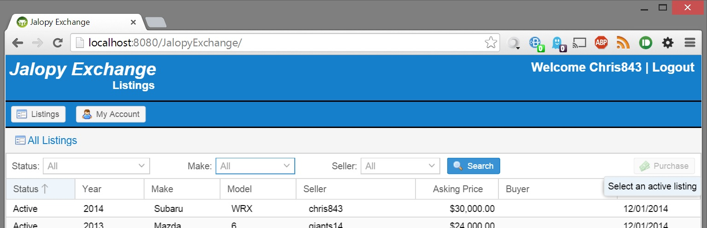

Confirmation displays listing information prior to completing the purchase

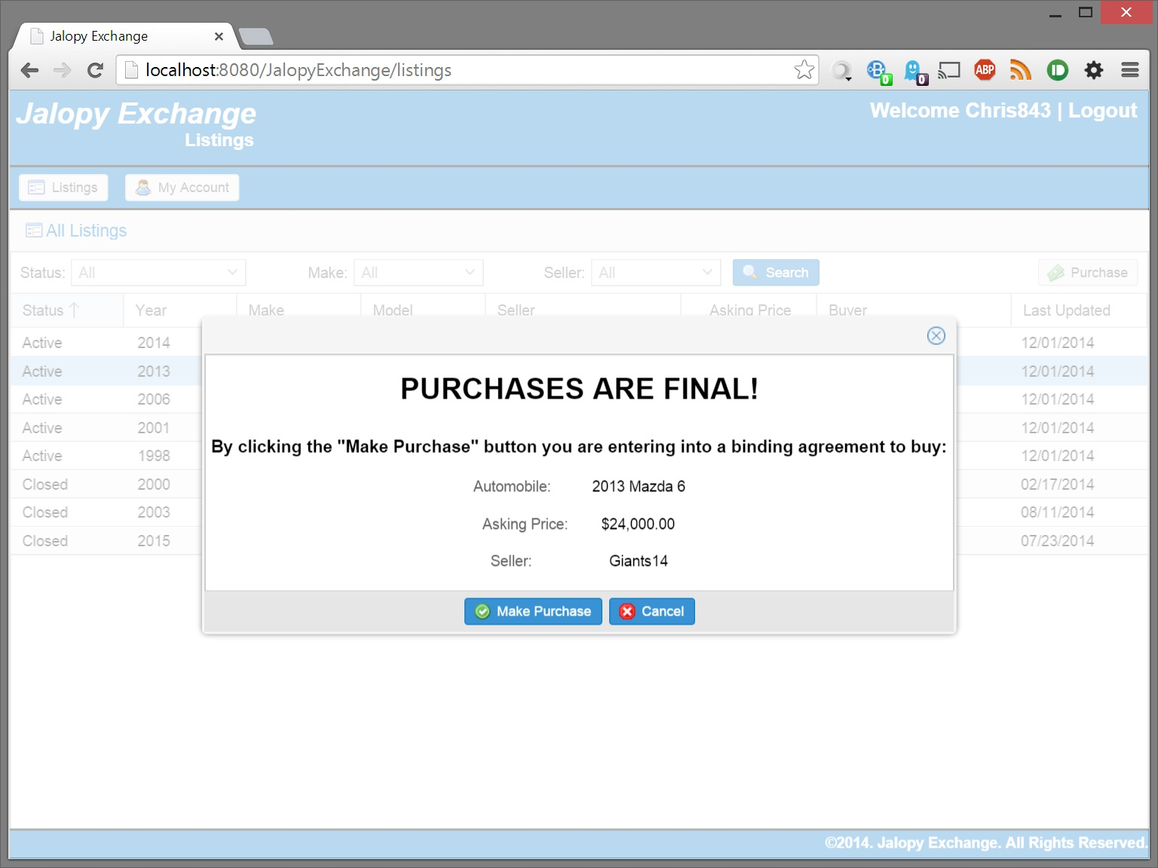

Success message displays after purchase is complete

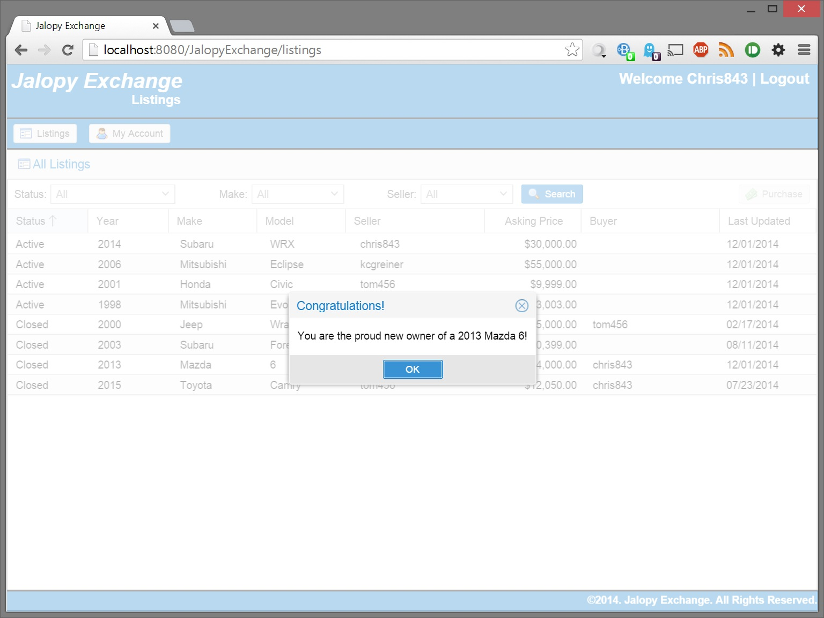

## Edit User Account Details

The system will not allow poorly formatted data to be saved (save button is disabled)

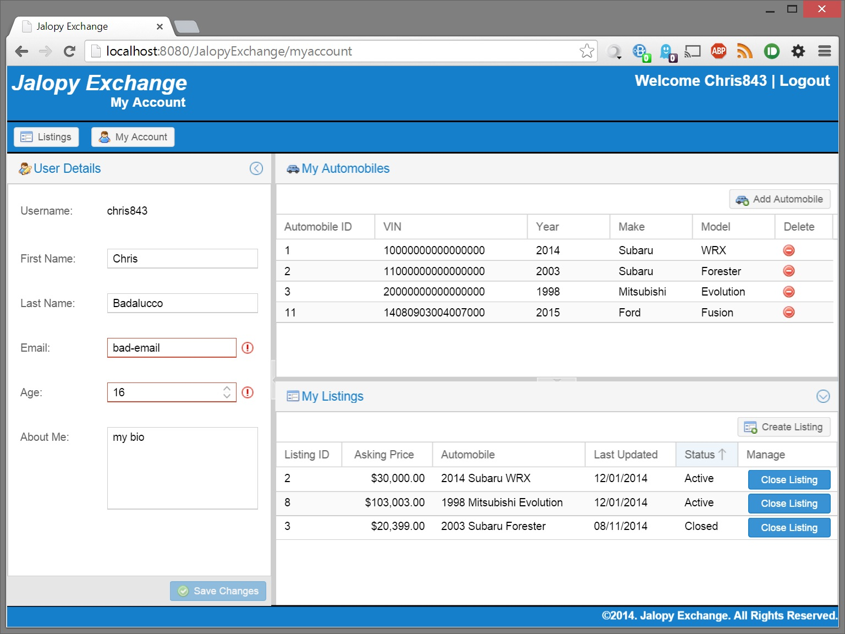

Minimum/Maximum age is enforced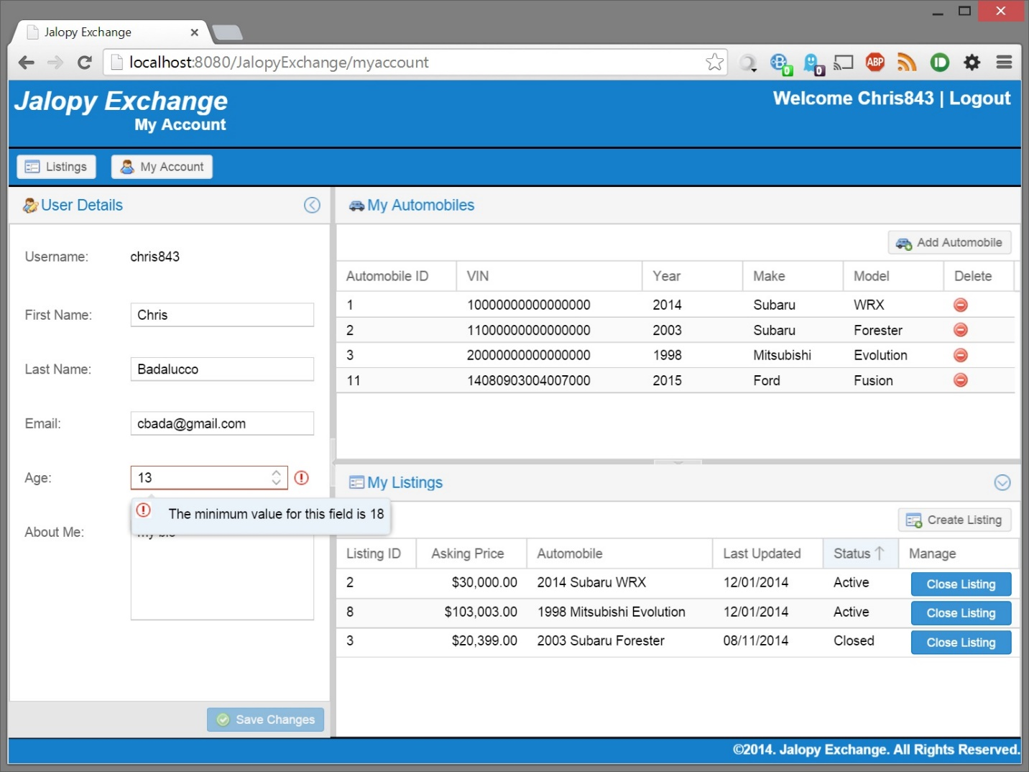

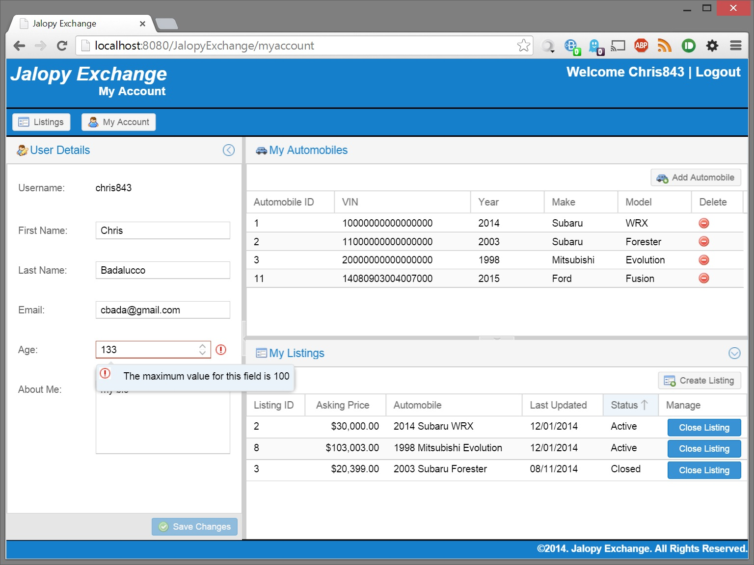

Correct email format is enforced

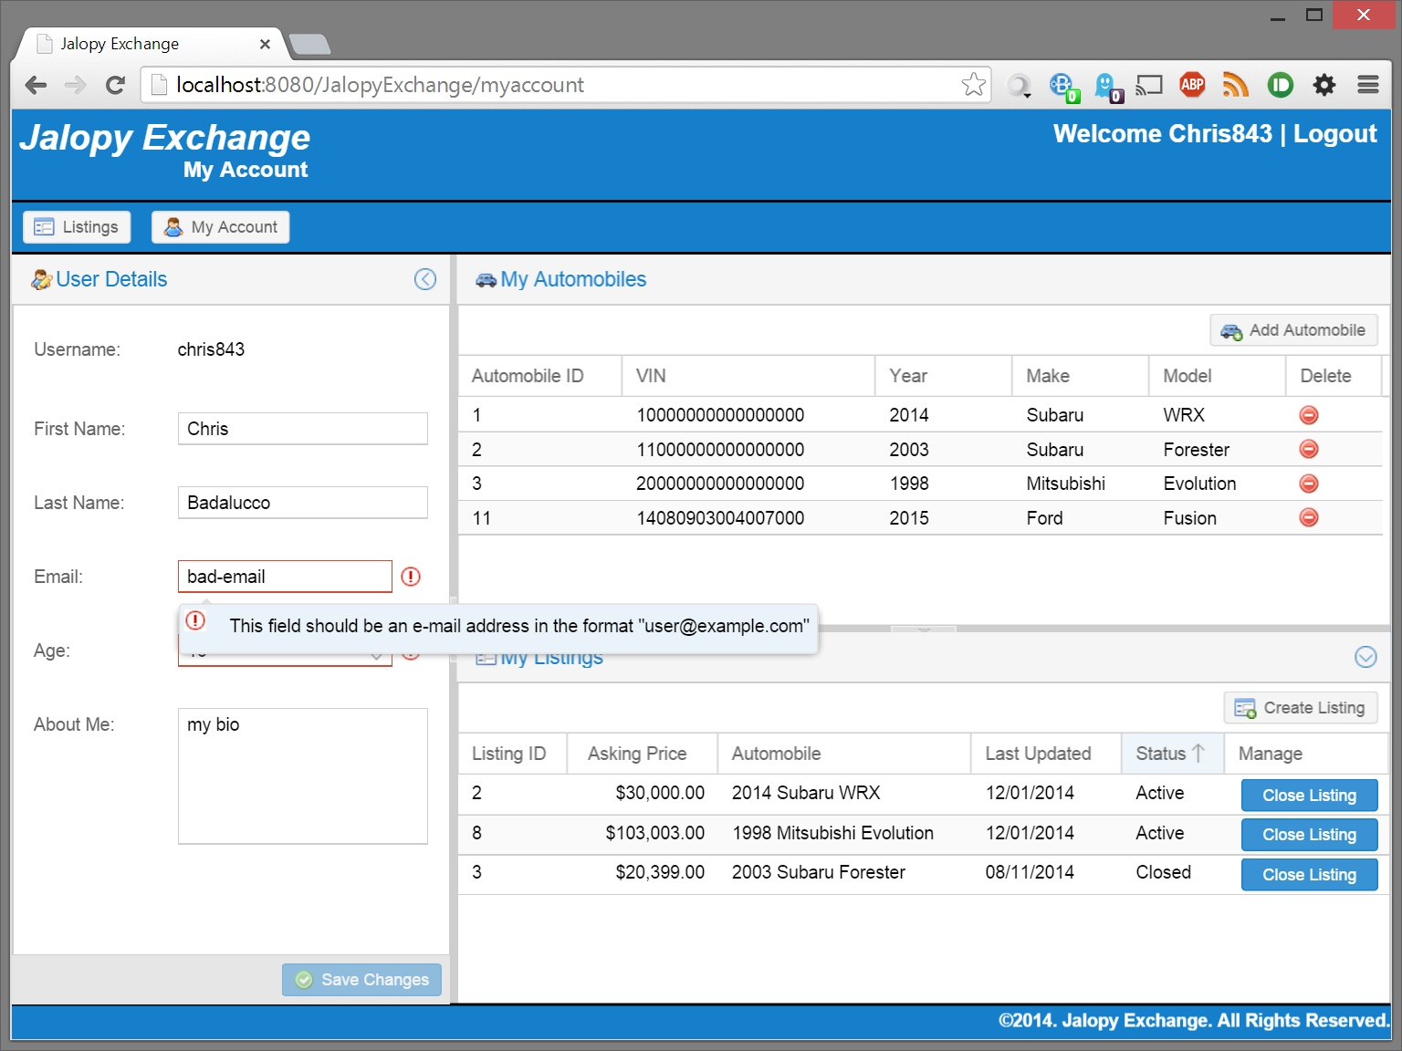

Confirmation prior to saving changes

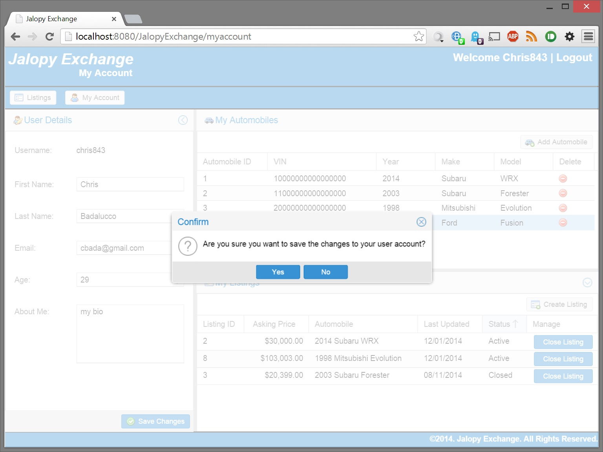

Success displays after saving changes

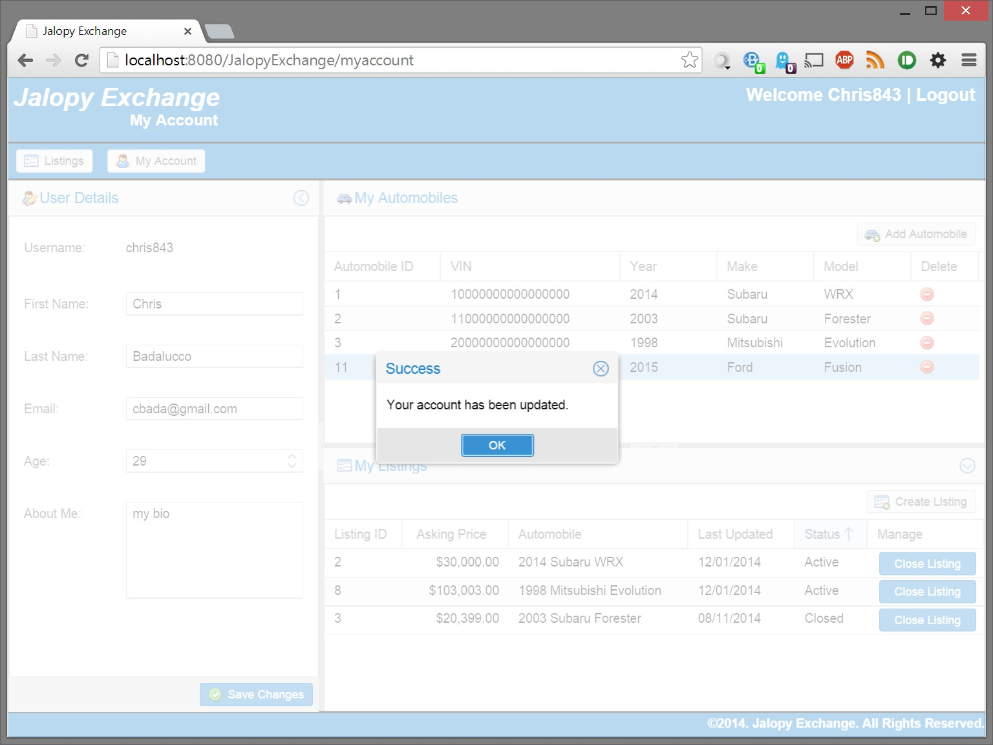

## Adding a New Automobile

The system will prevent poorly formatted data from being sent to the server (submit button is disabled)

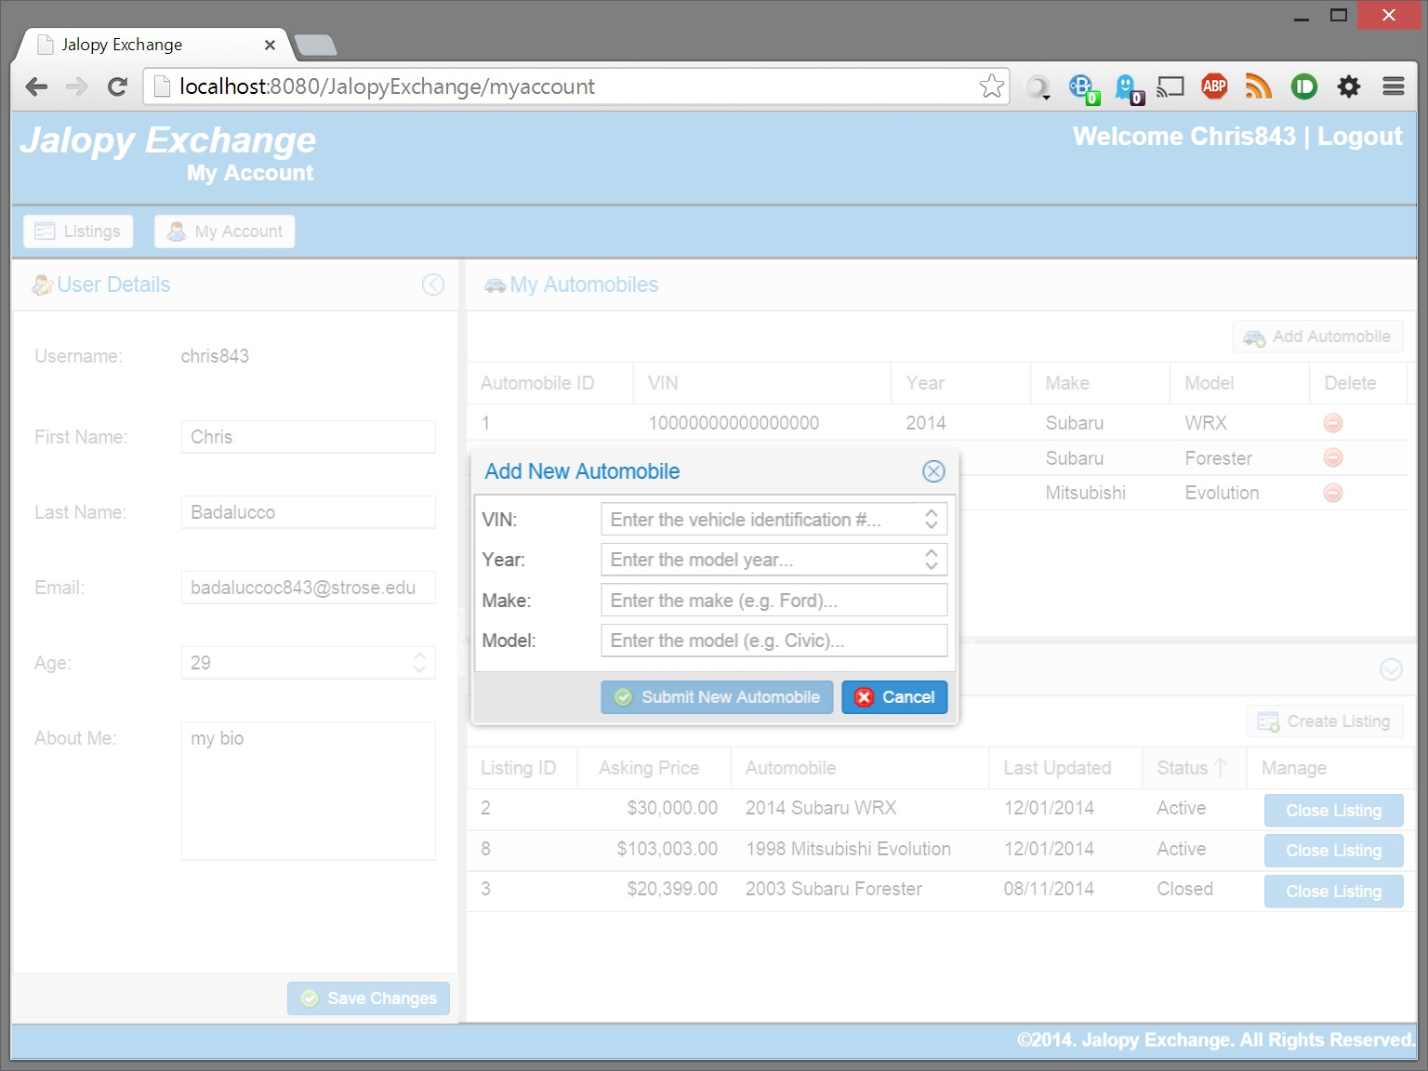

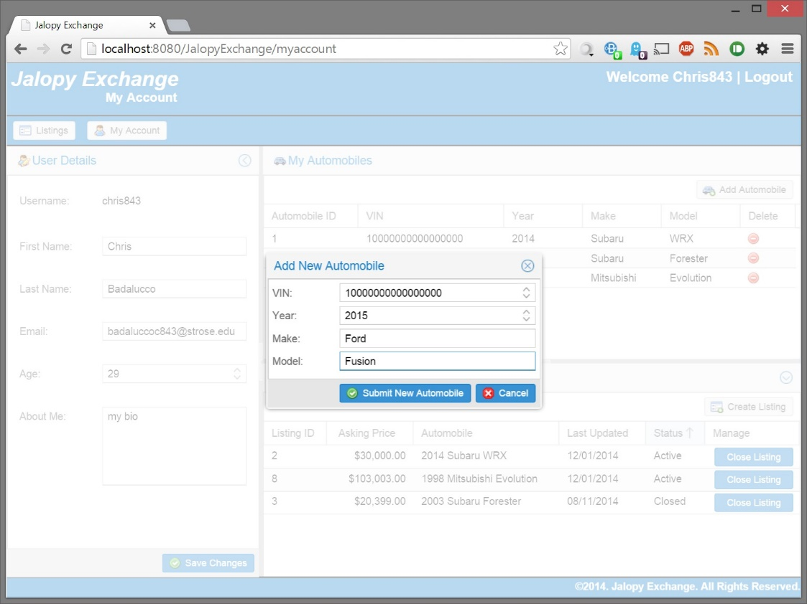

Maximum / Minimum size VIN enforced

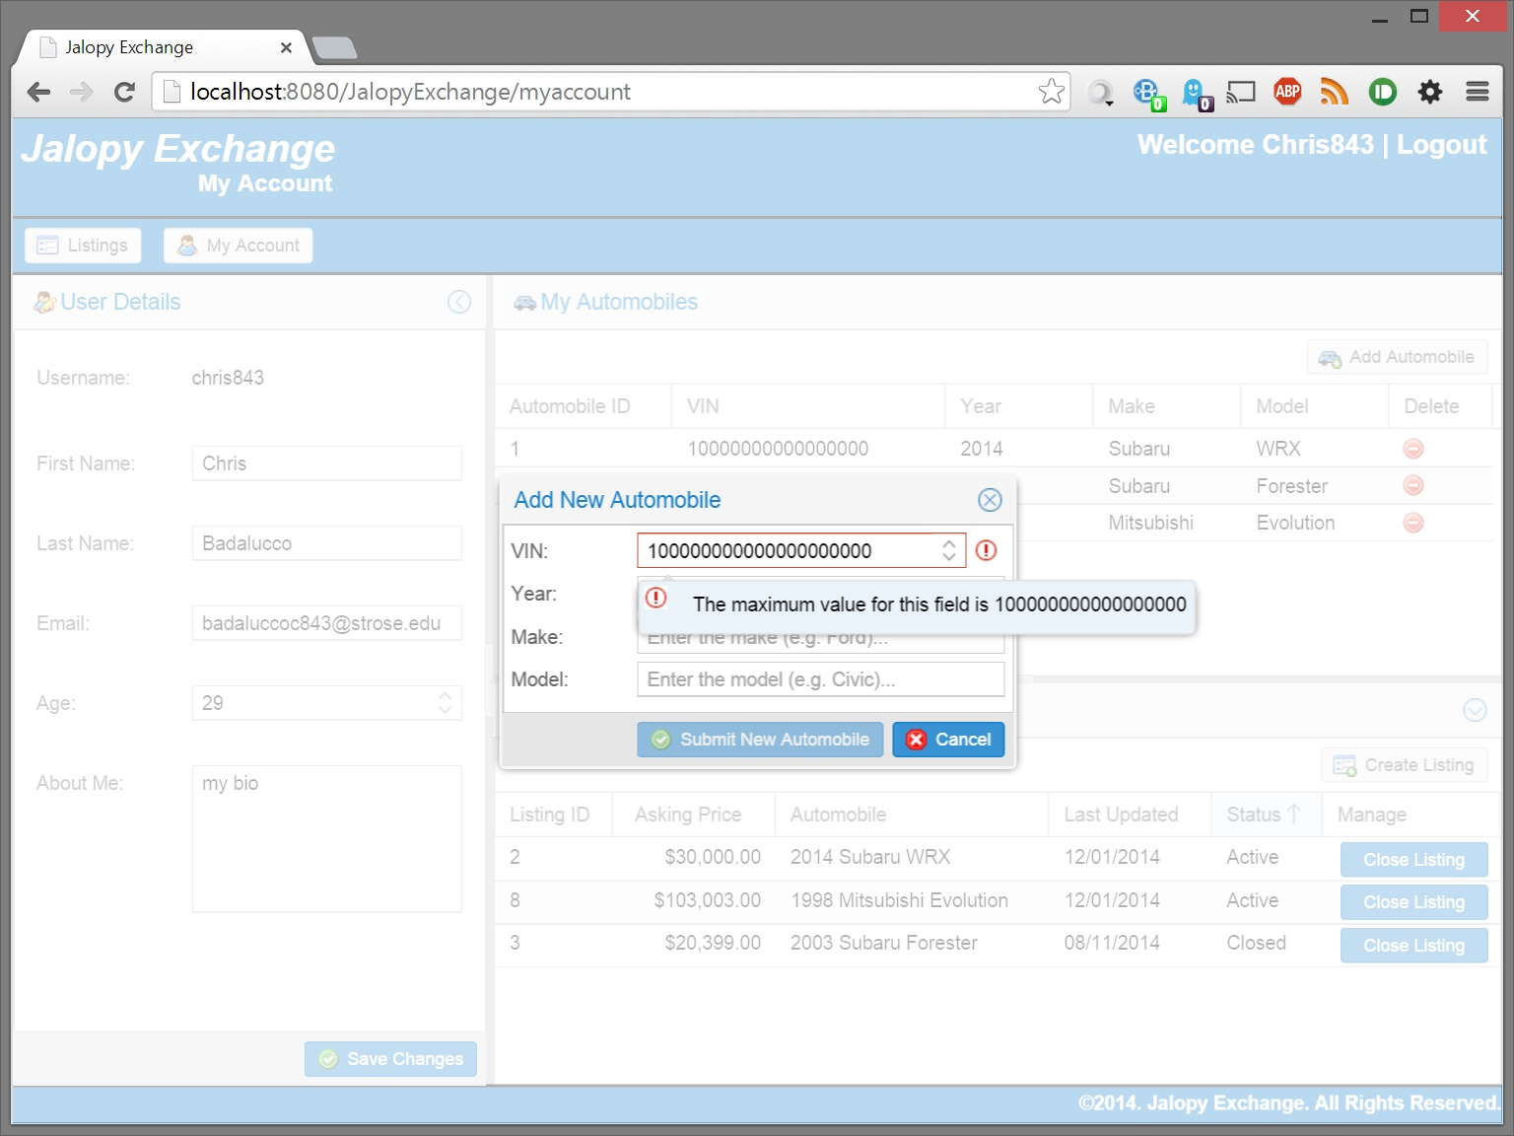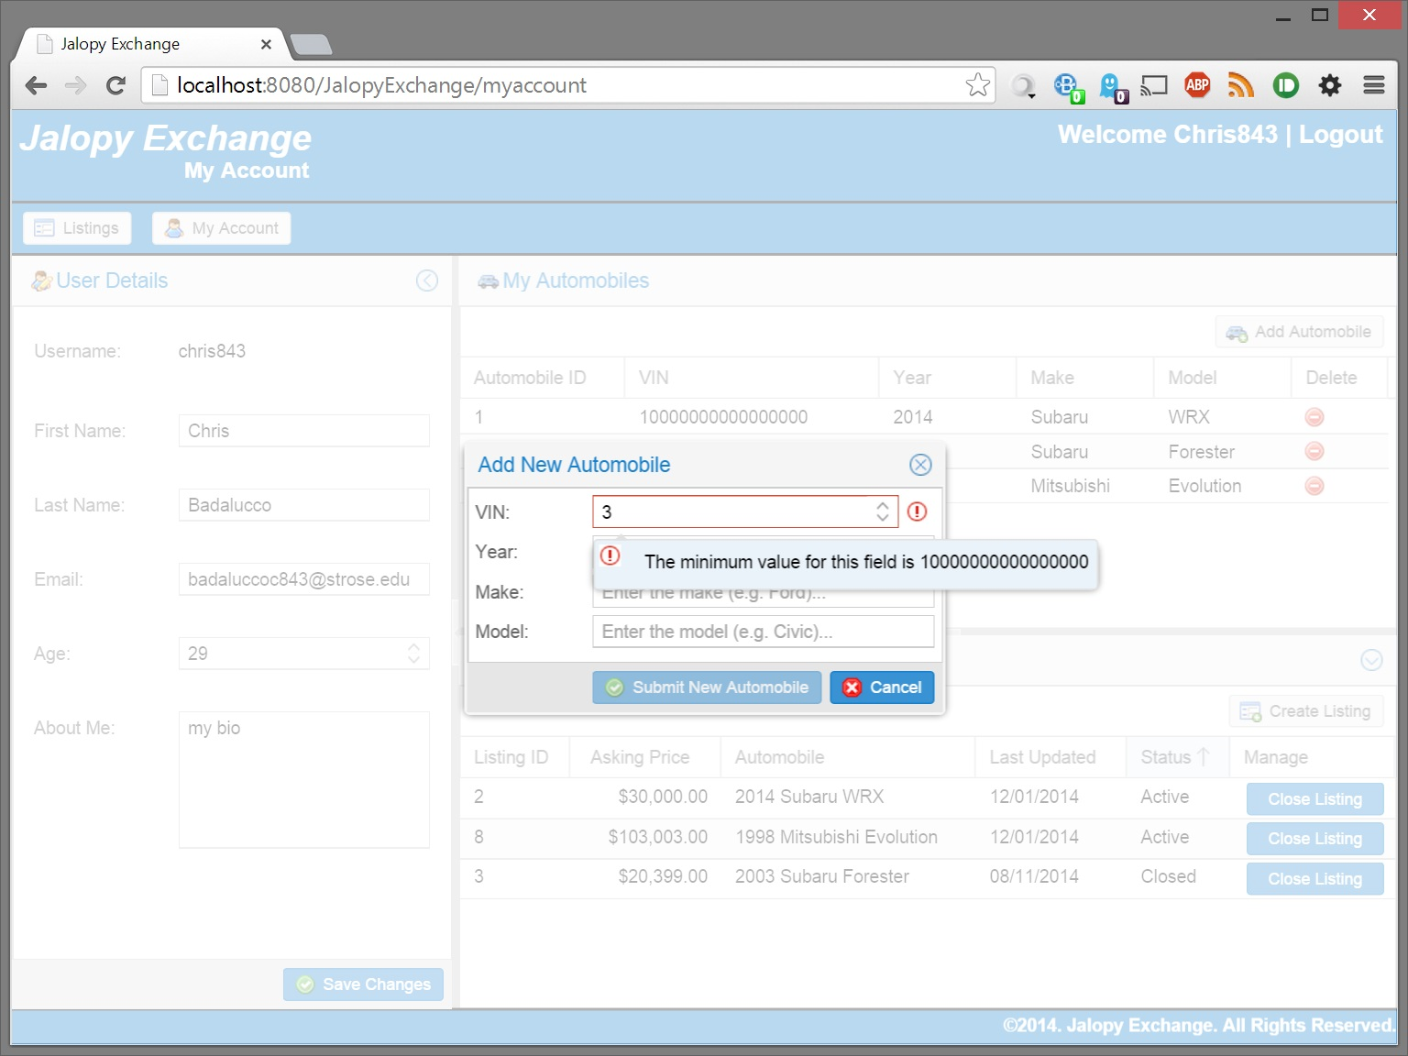

Minimum/Maximum year enforced. Maximum year is current year + 1

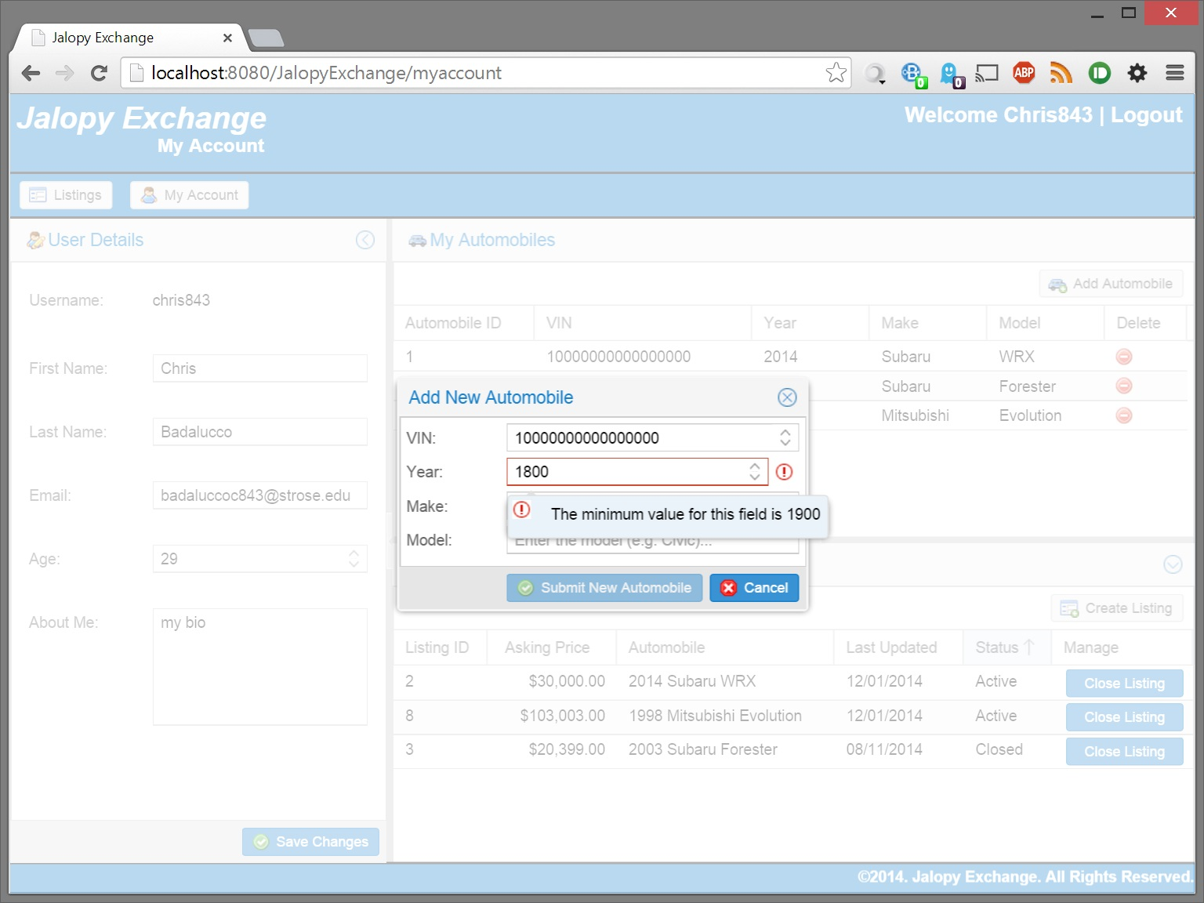

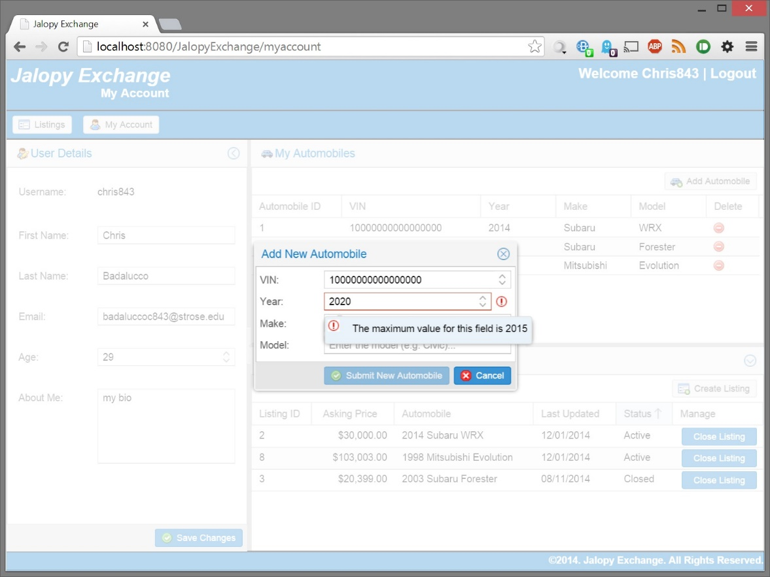

Automobile VIN must be unique

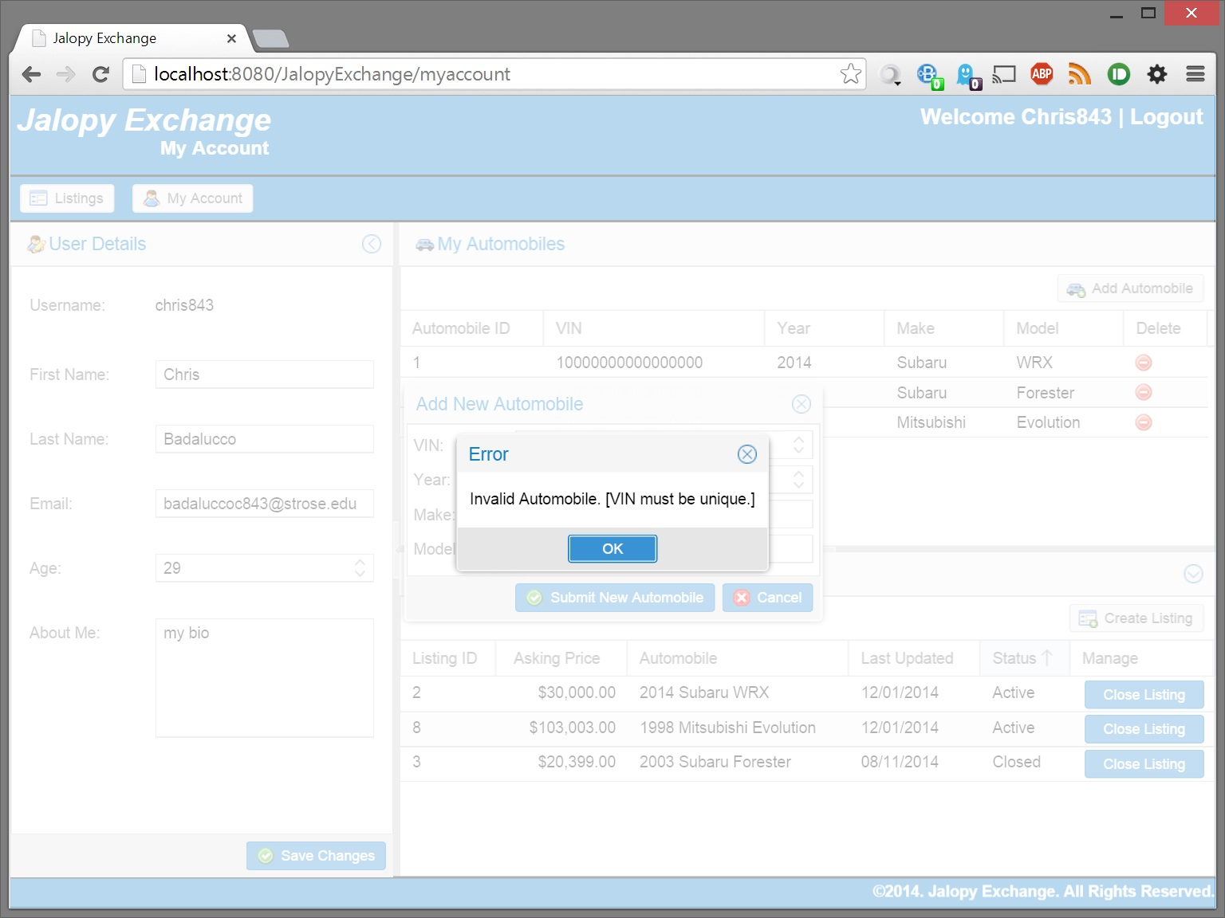

Success displayed after data is saved

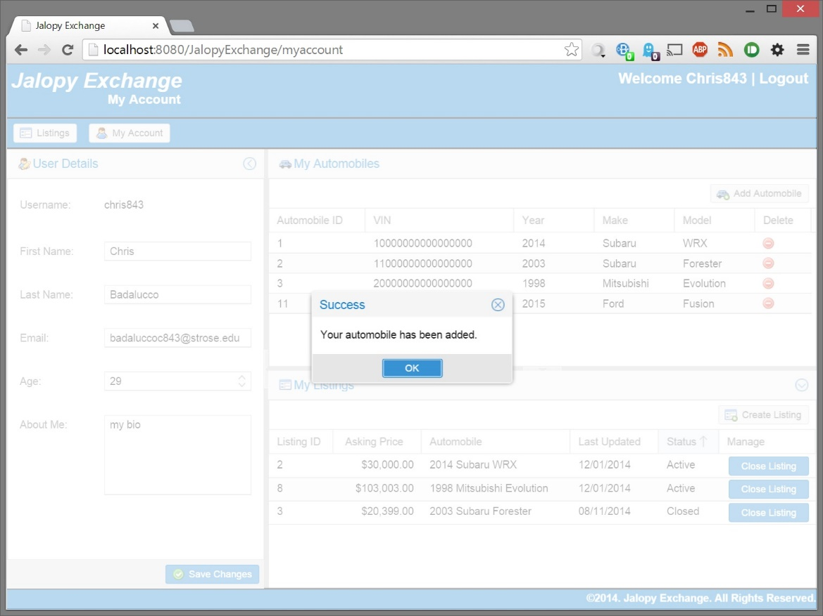

## Deleting an Automobile

Confirmation prior to completing the delete

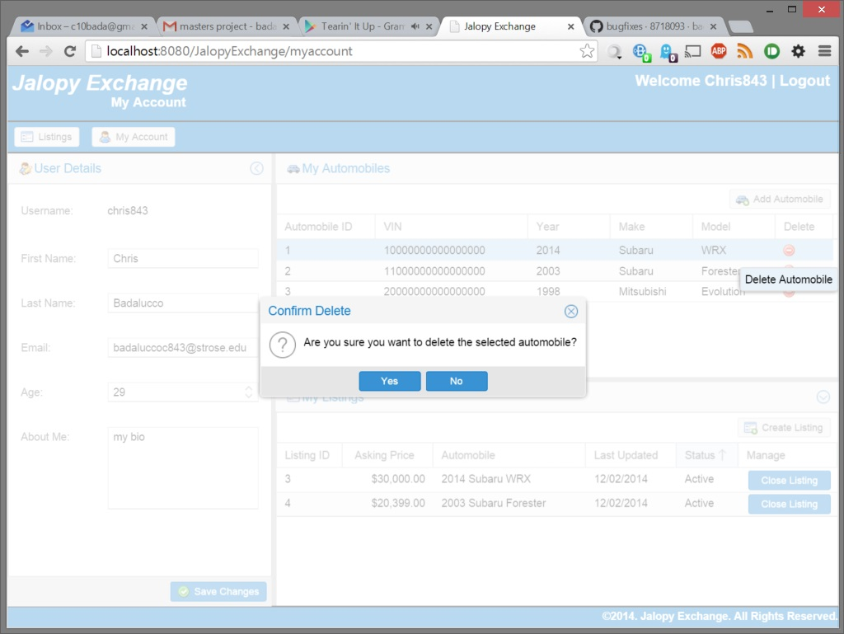

Success after the delete is completed

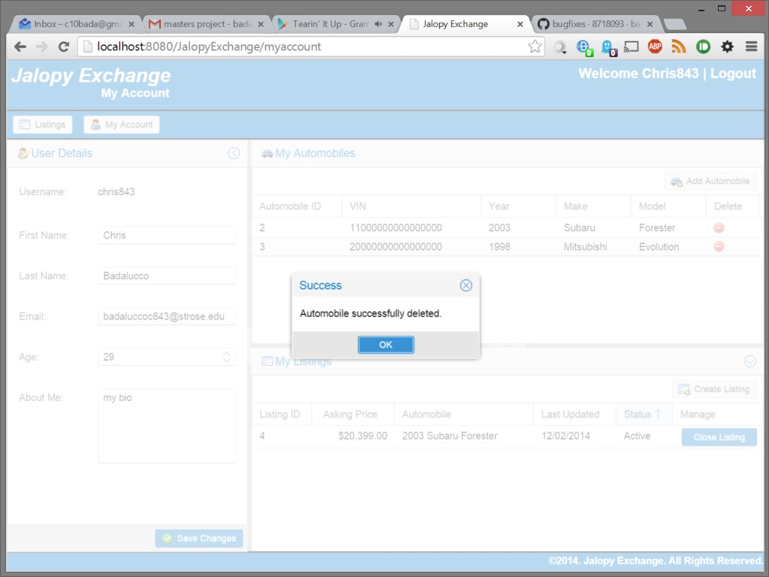

## Adding a New Listing

The system will prevent poorly formatted data from being sent to the server (submit button is disabled)

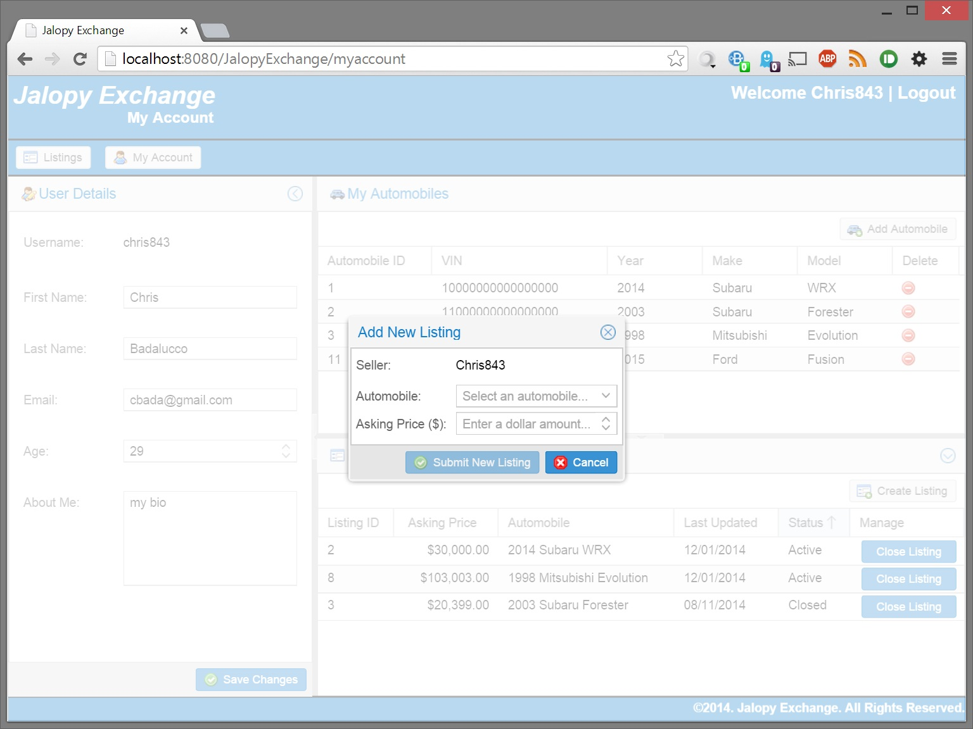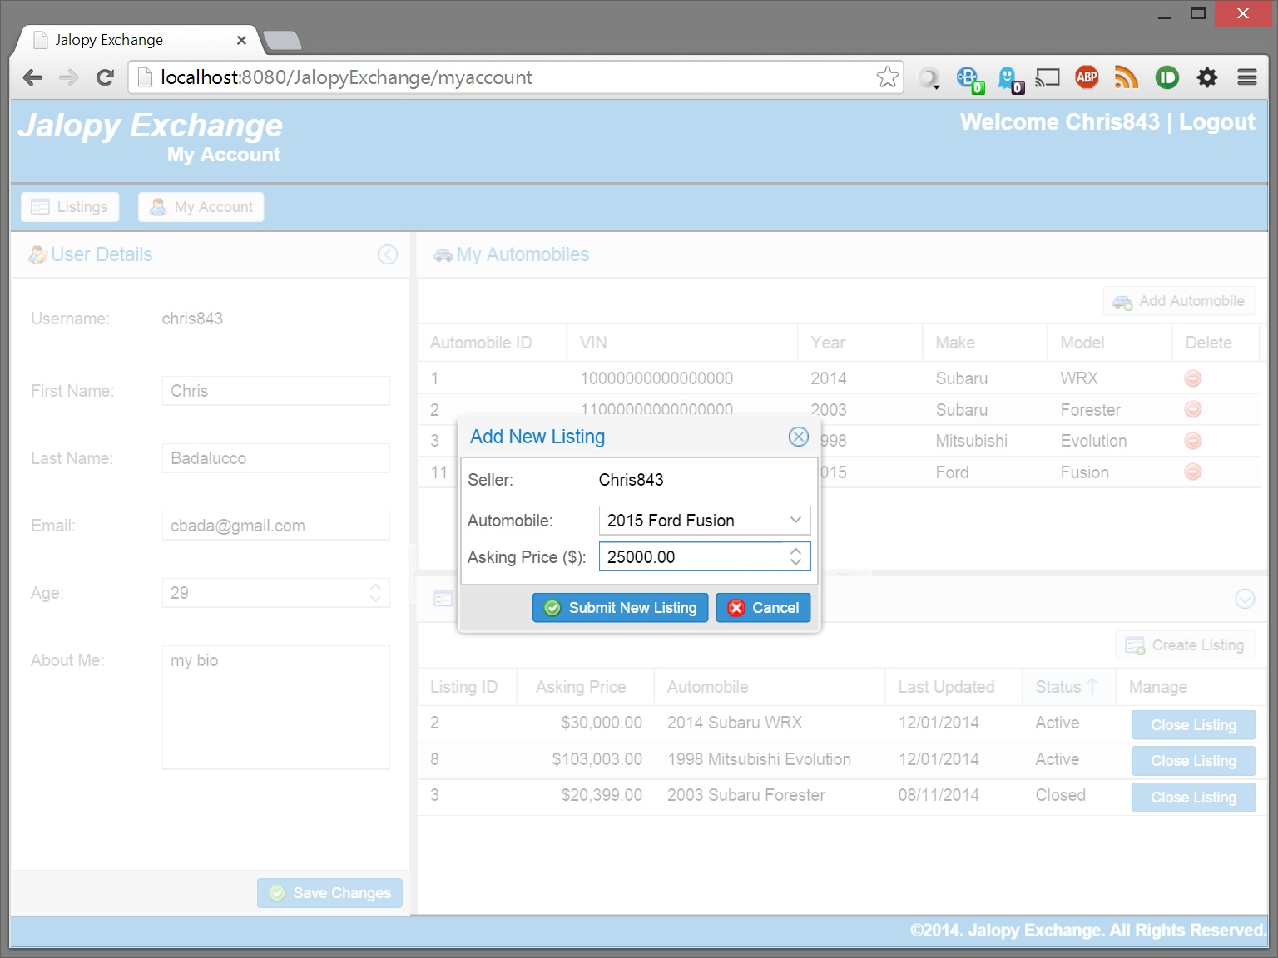

Automobile is a required field

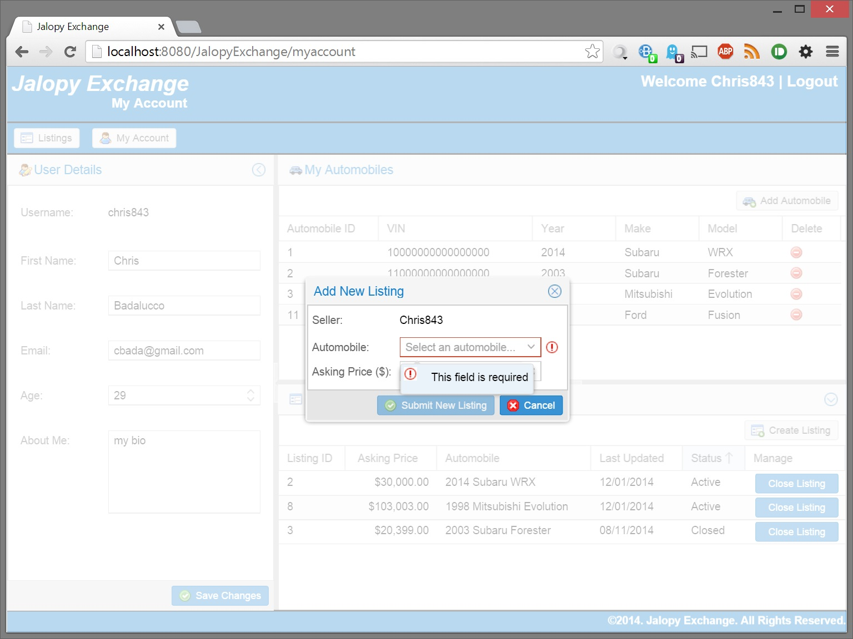

Price is a required field

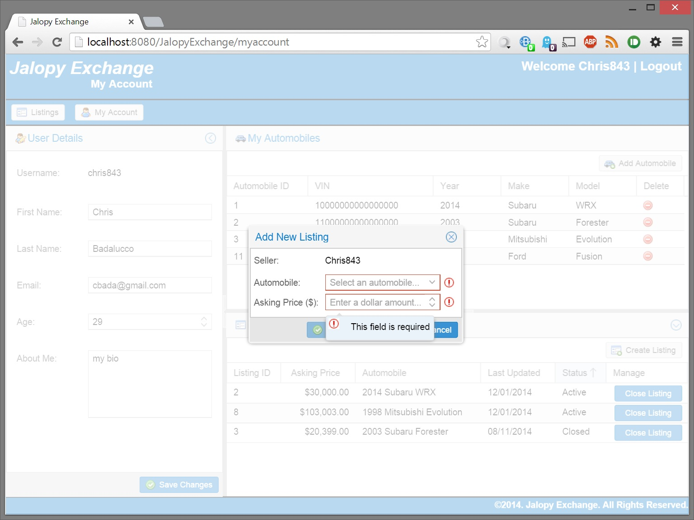

Minimum/Maximum price validations must be met

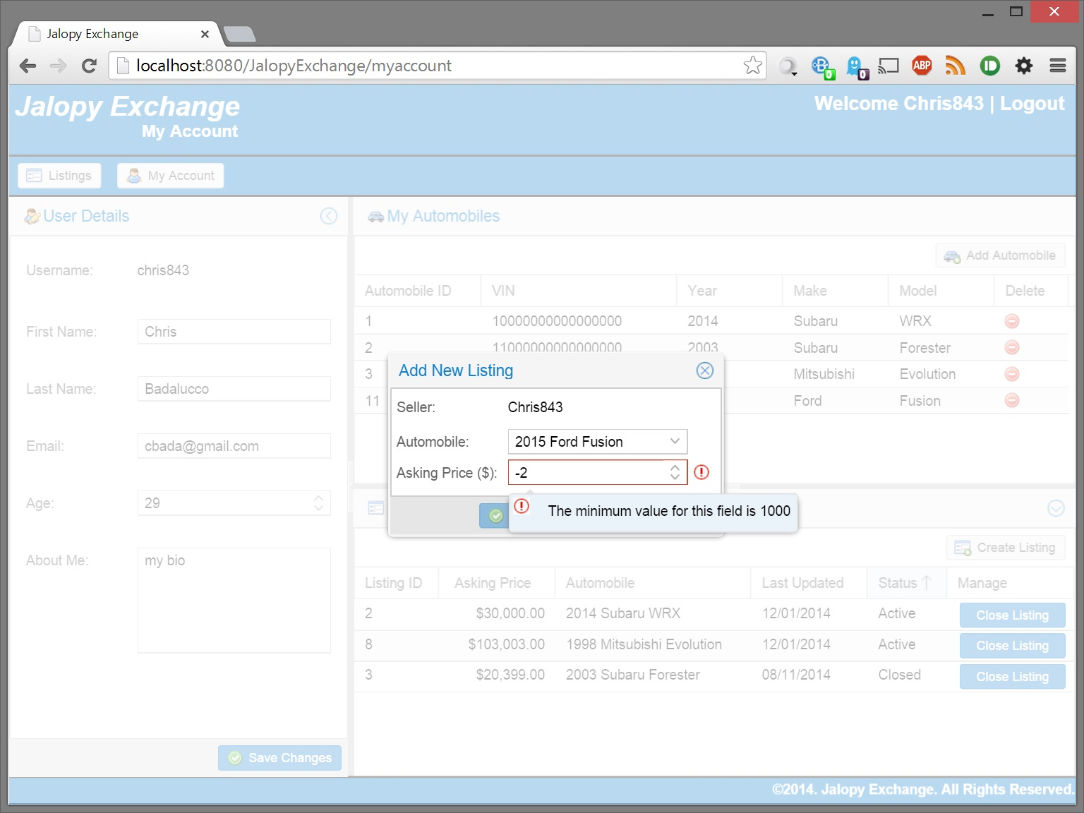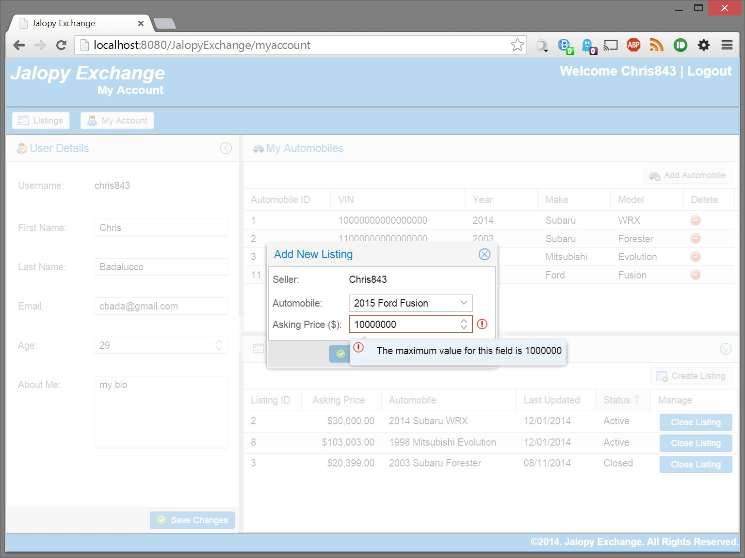

Success message displayed once data is saved

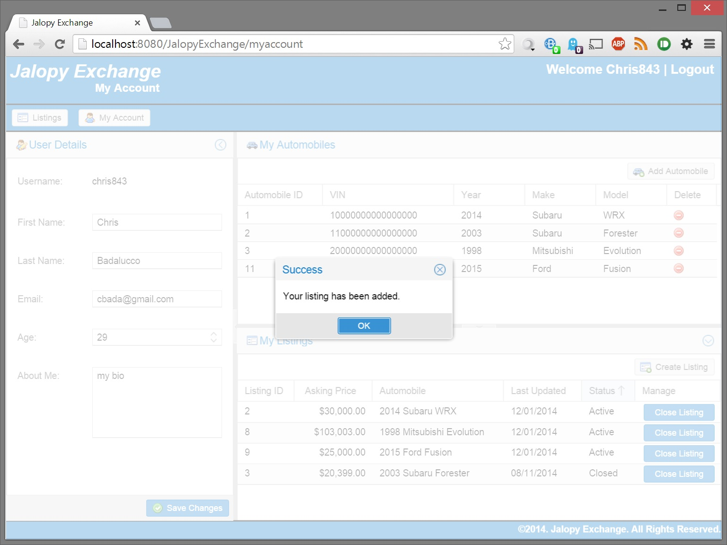

## User Closing Listing

A user can close their own open listings

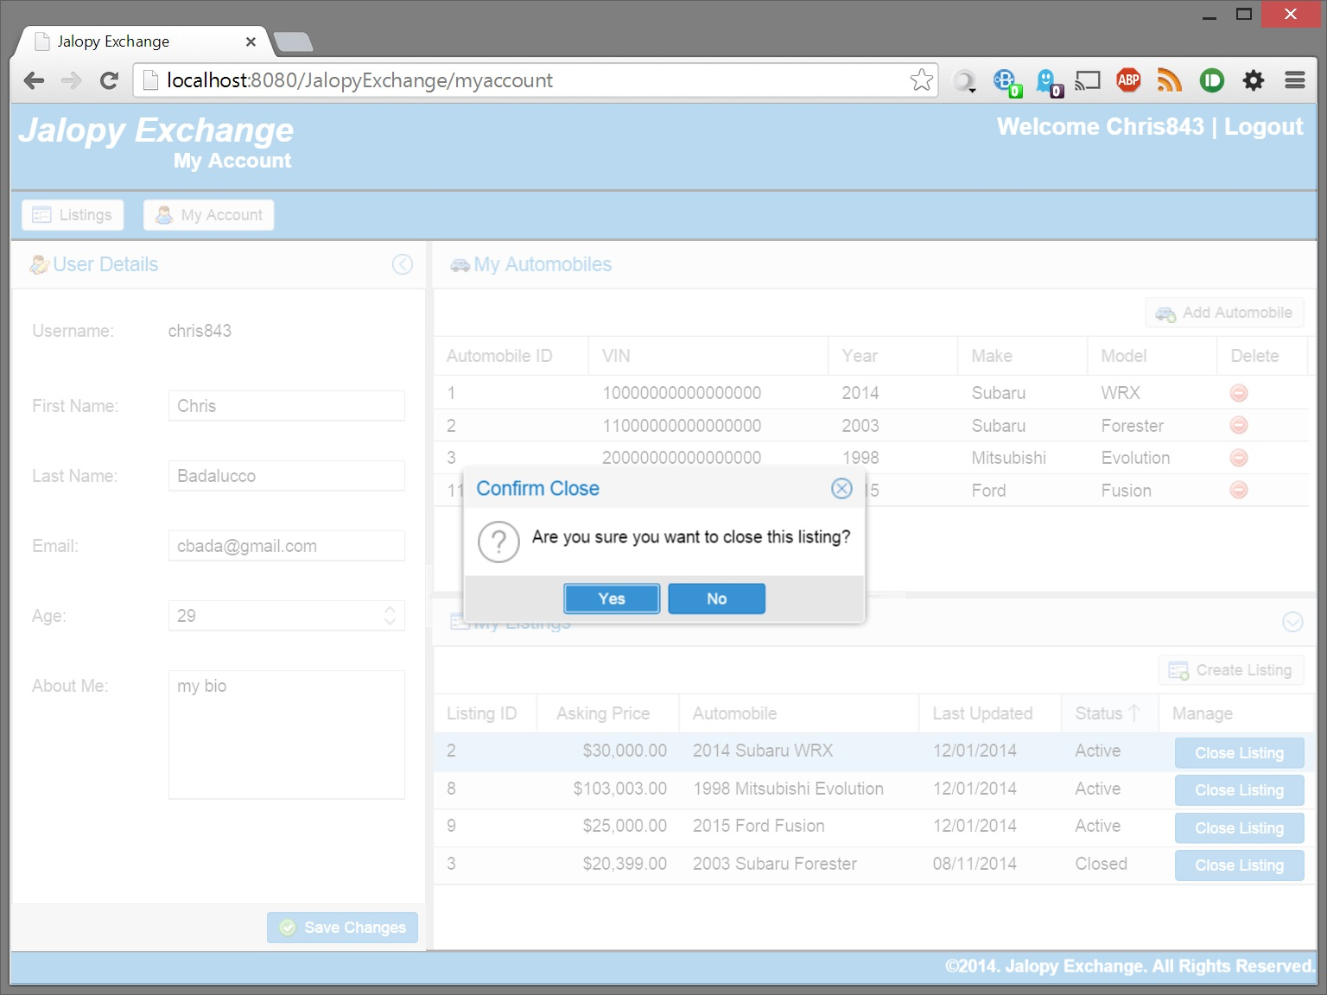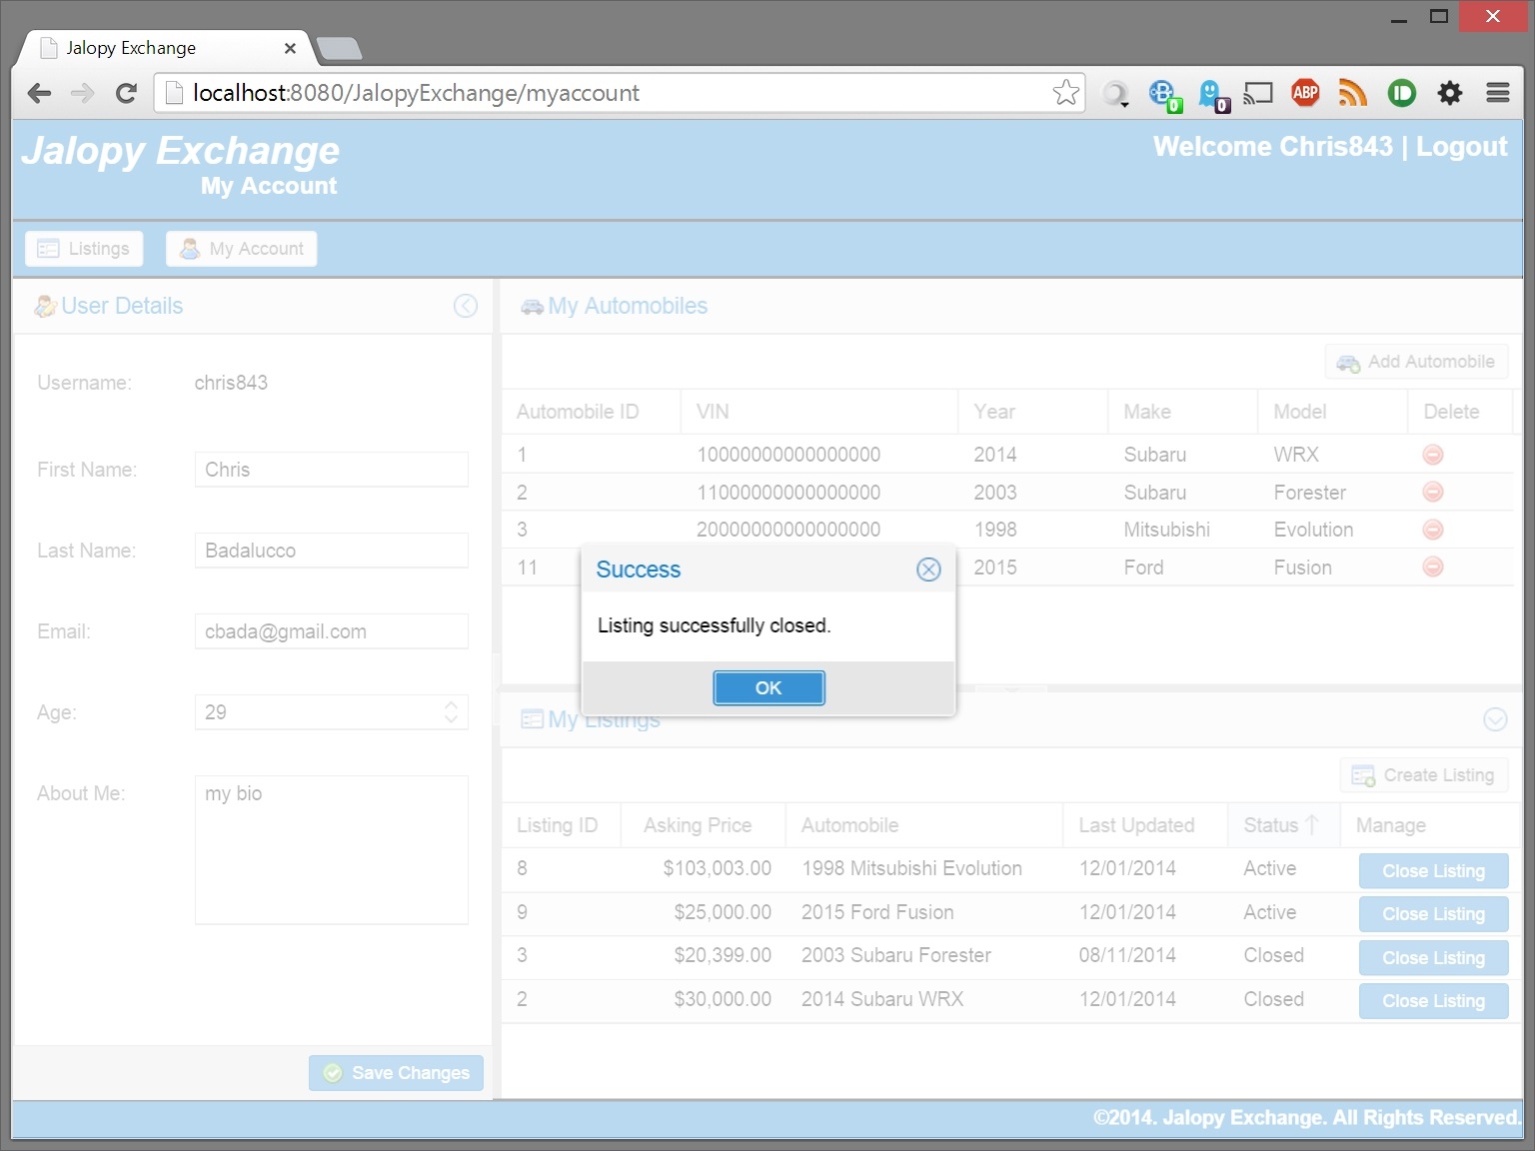

Can only close open listings

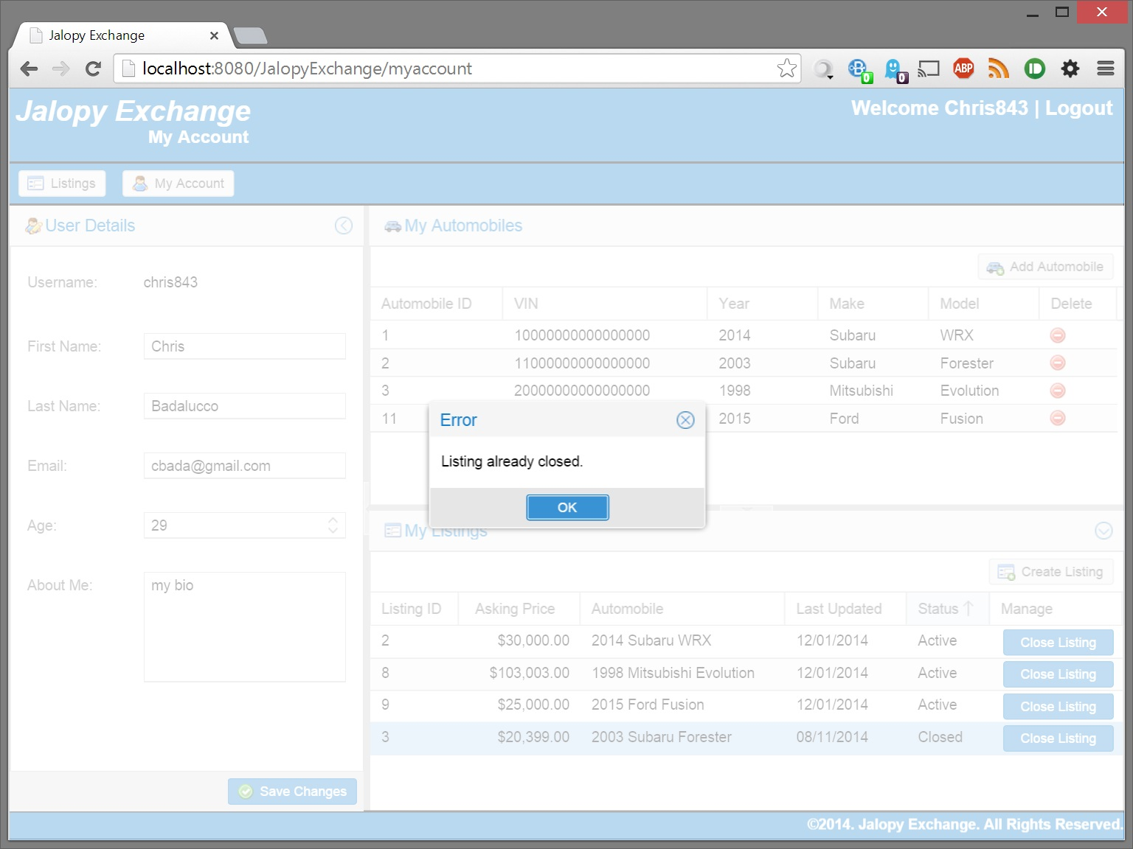

# Admin Specific Tasks

## Listings Screen has admin specific abilities

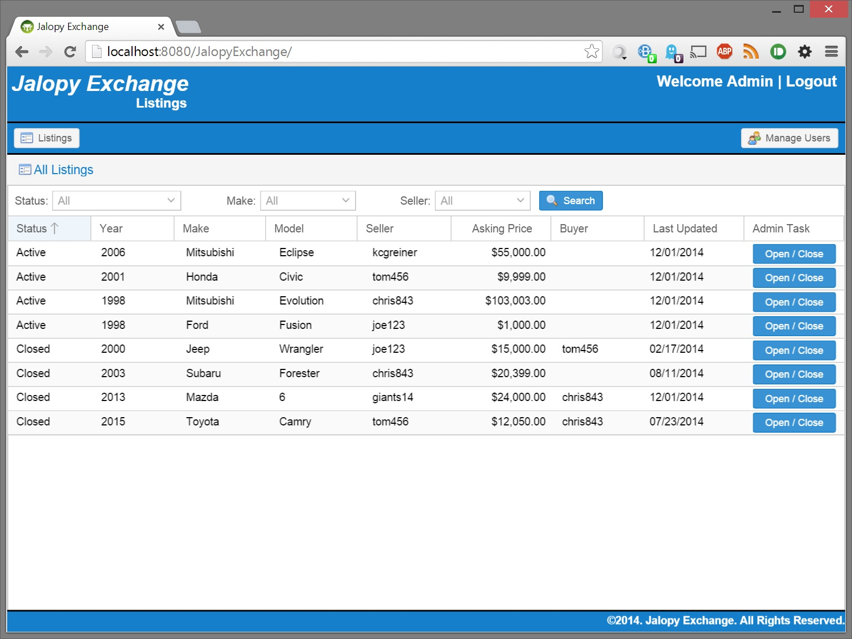

Close an Active Listing

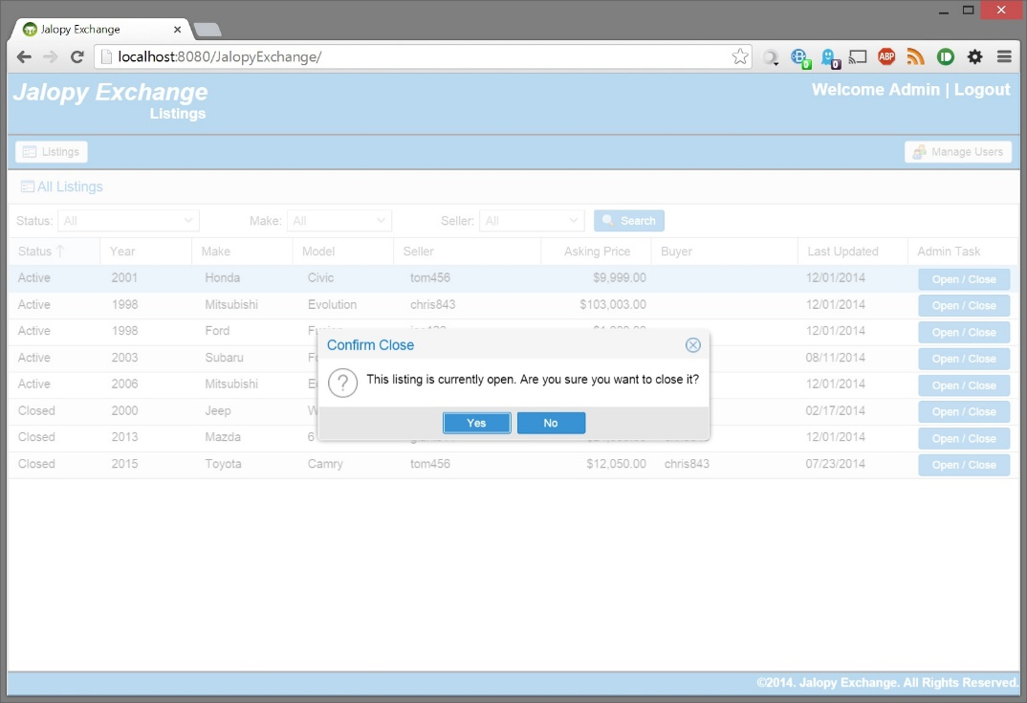

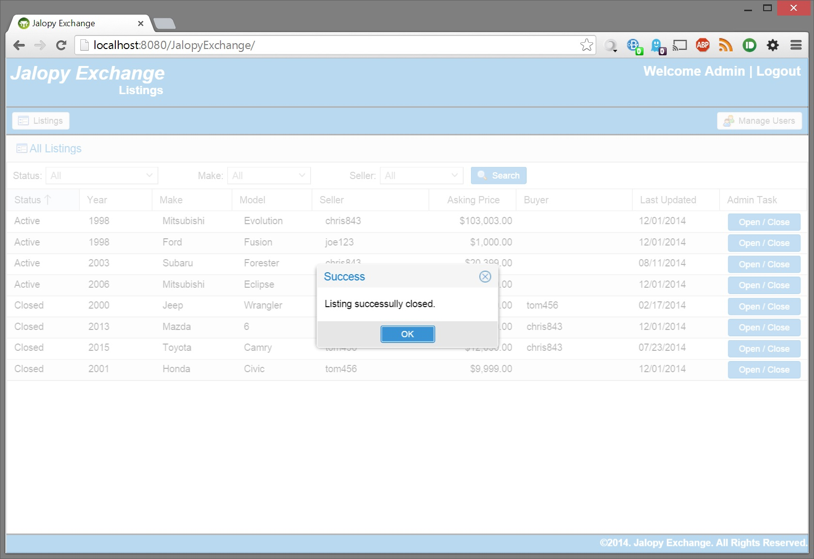

Open a Closed Listing

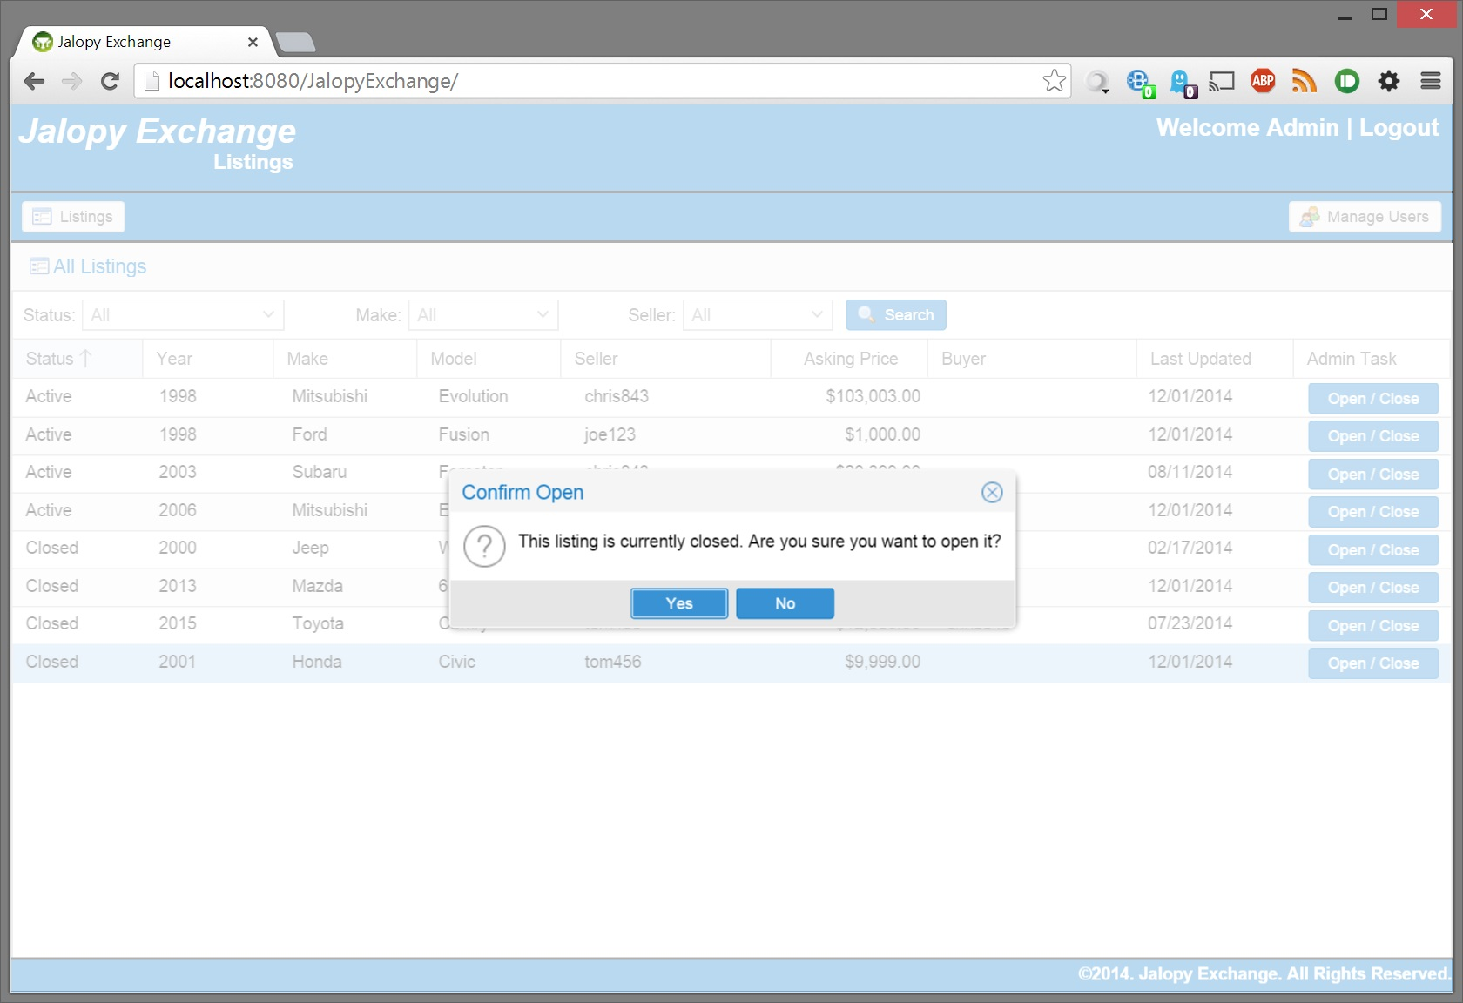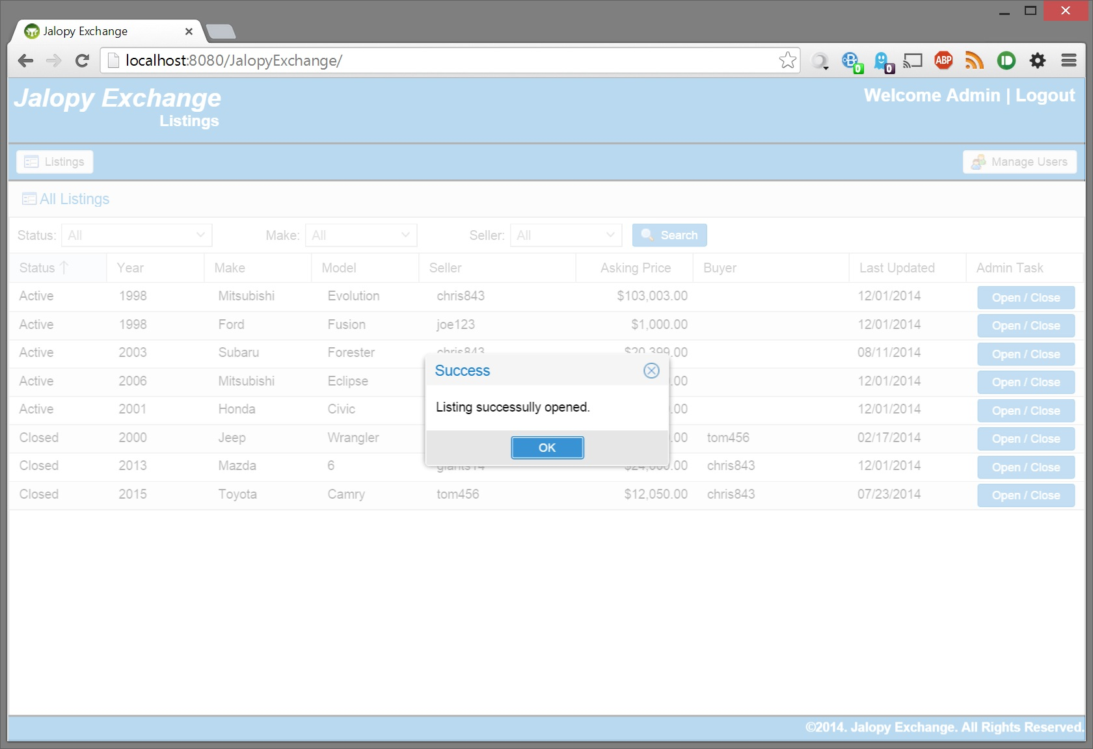

## Manage users screen

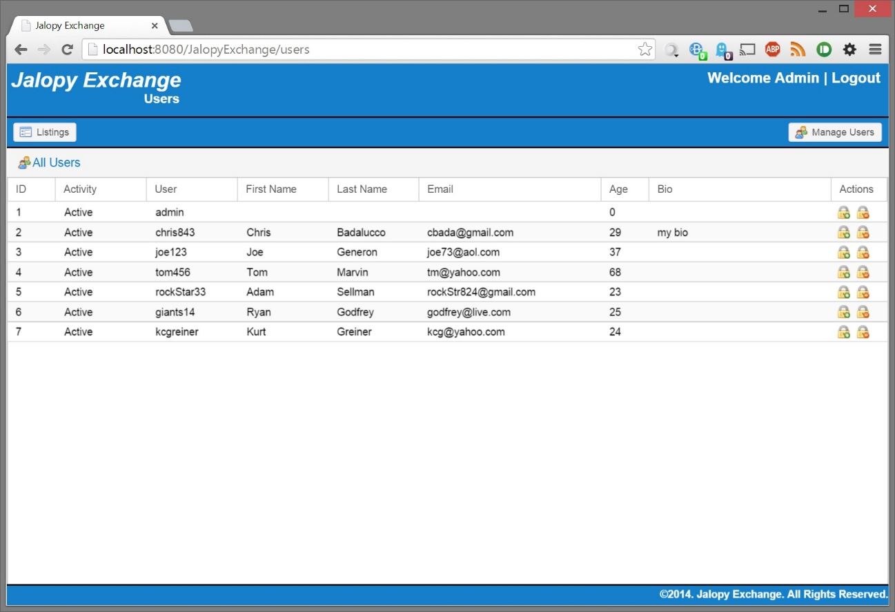

Confirm Admin cannot lock themselves

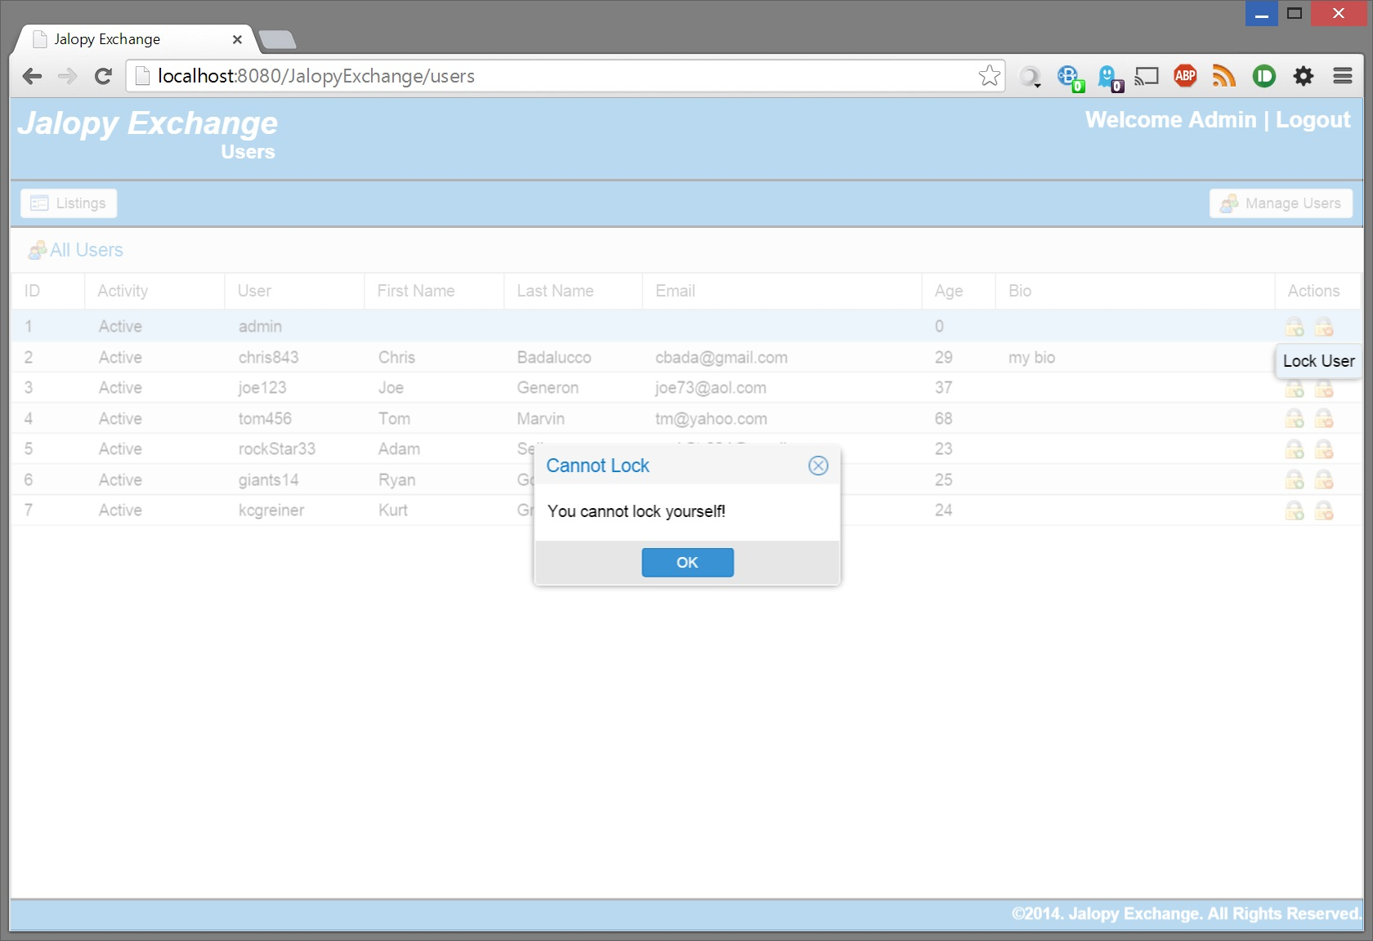

Confirm cannot lock an already locked account

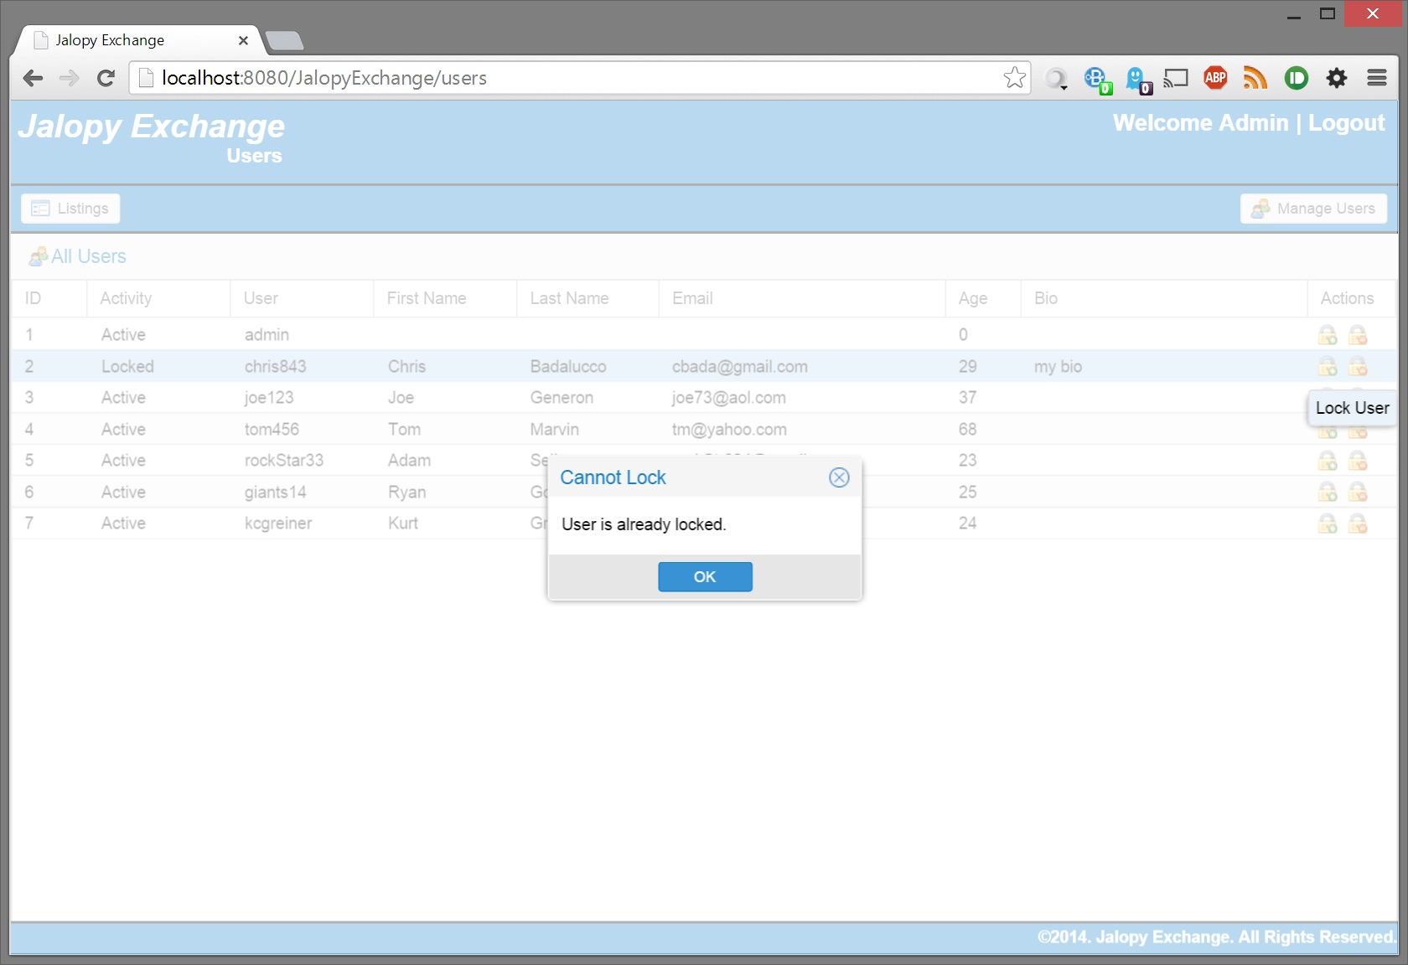

Confirm cannot unlock an already unlocked (active) account

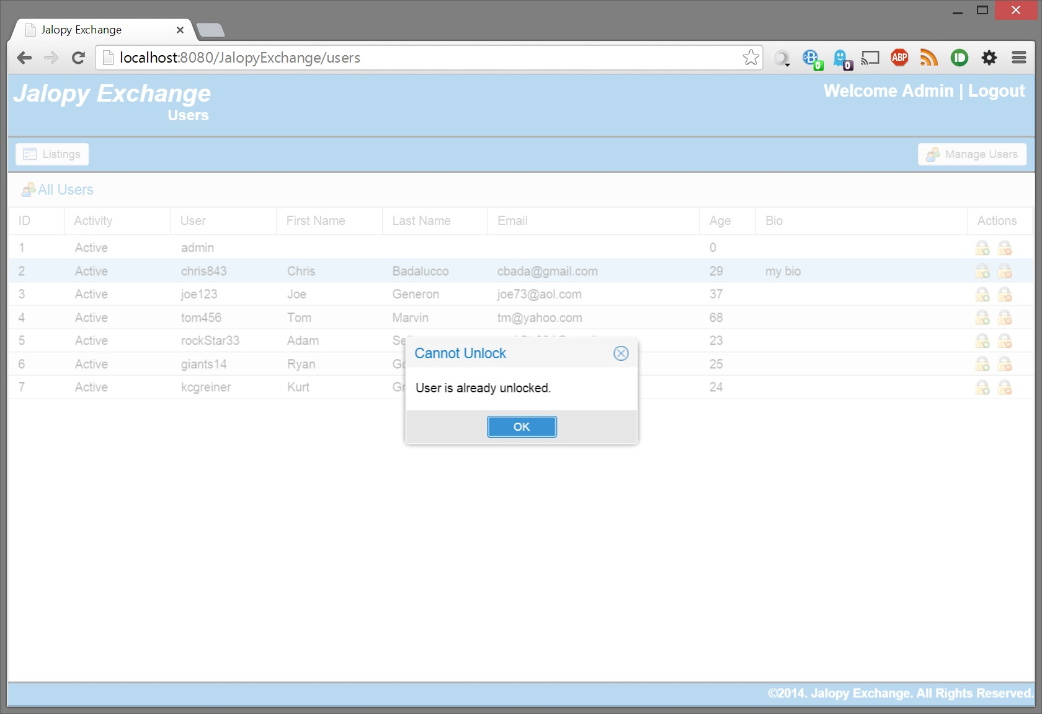

Lock an account

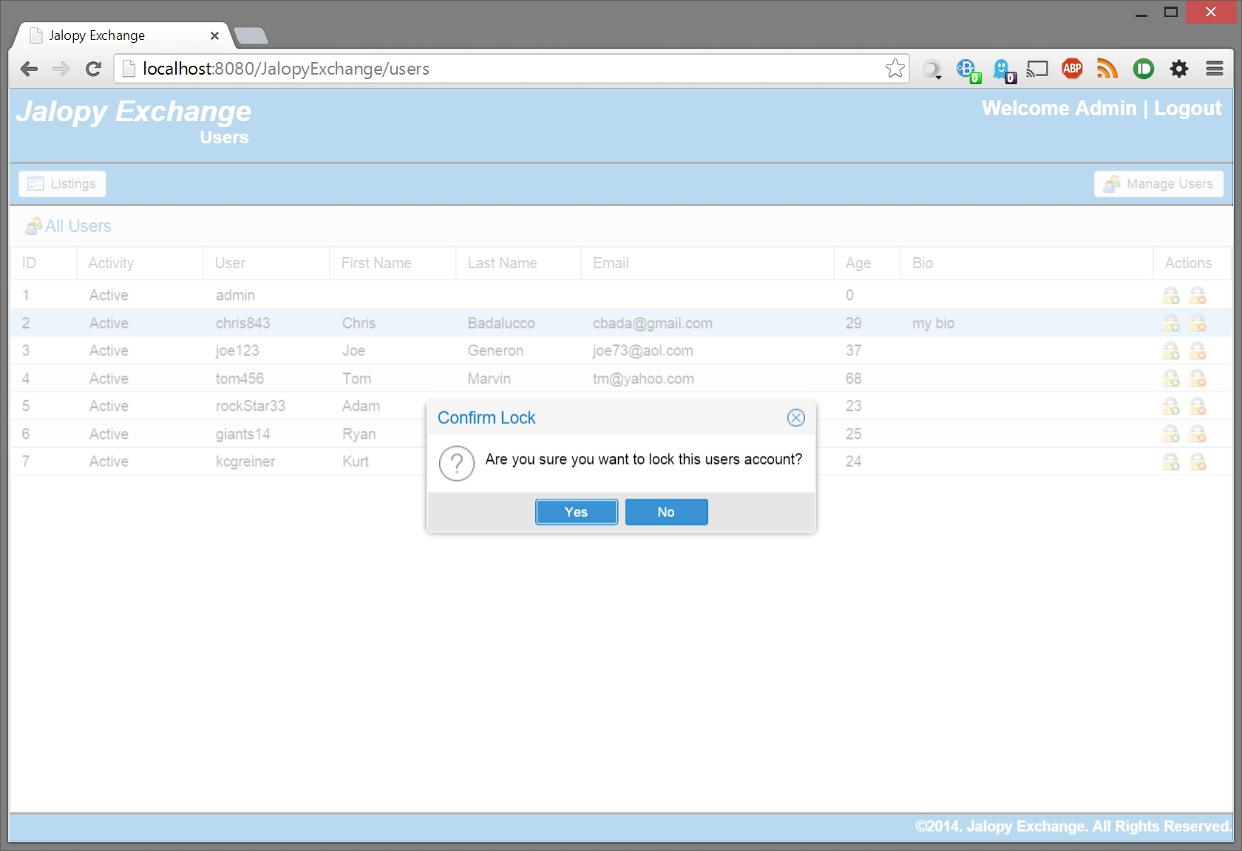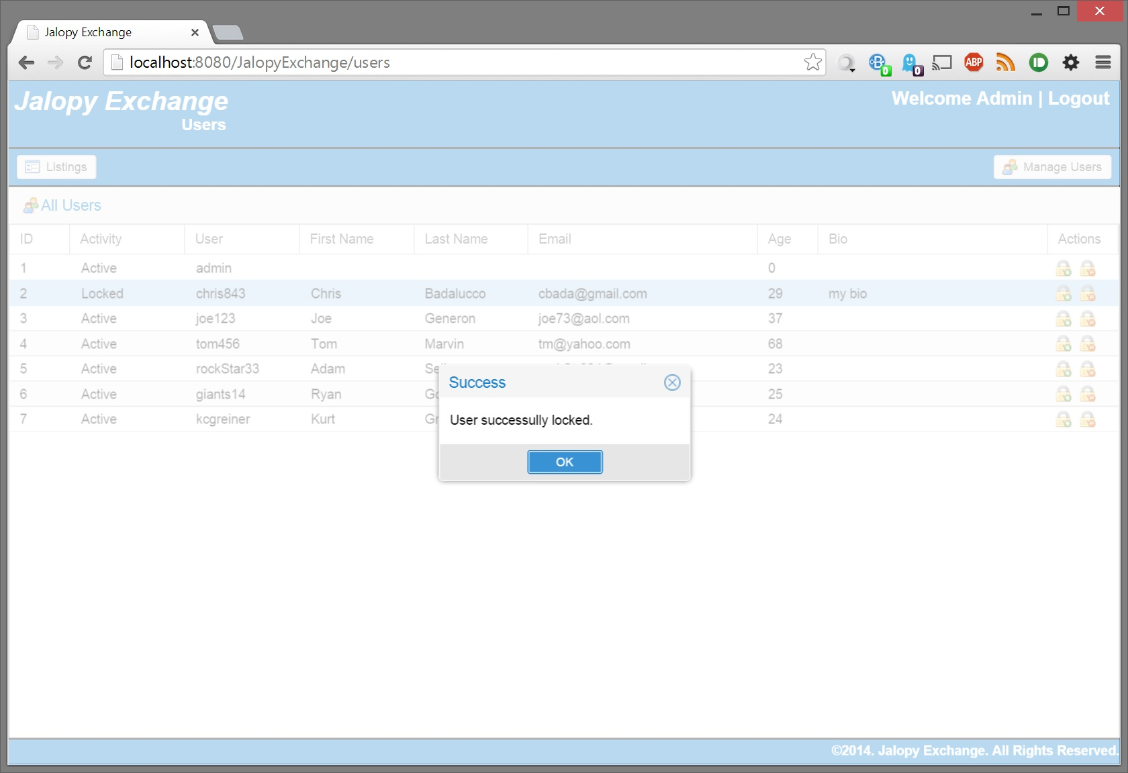

Unlock a locked account

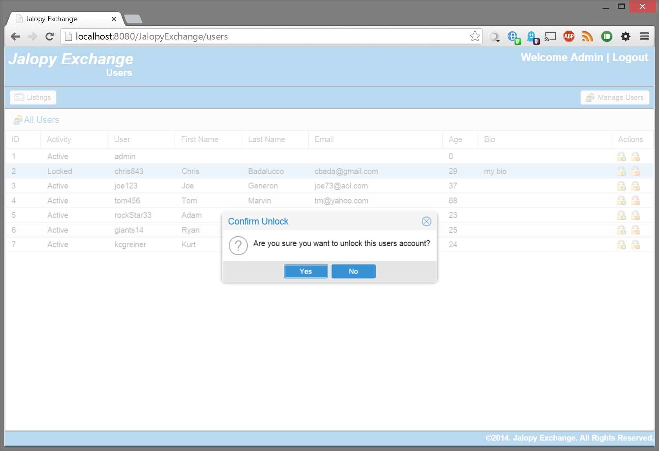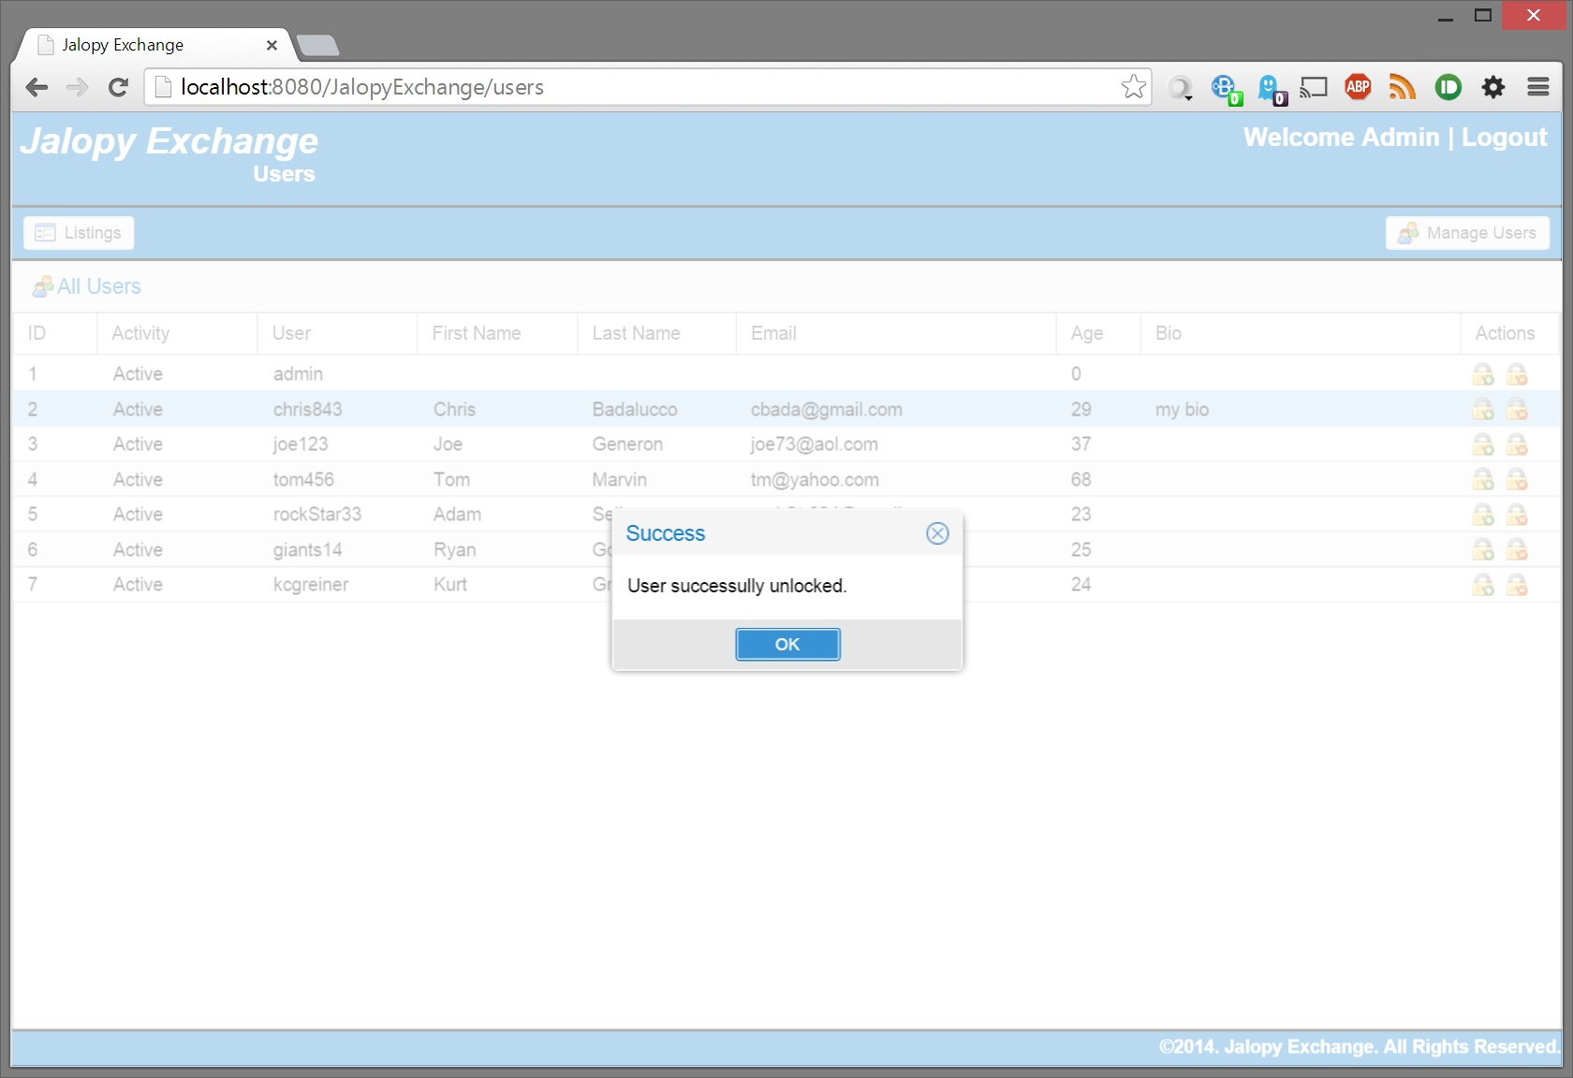

Admin can edit all the user’s details except for username and password

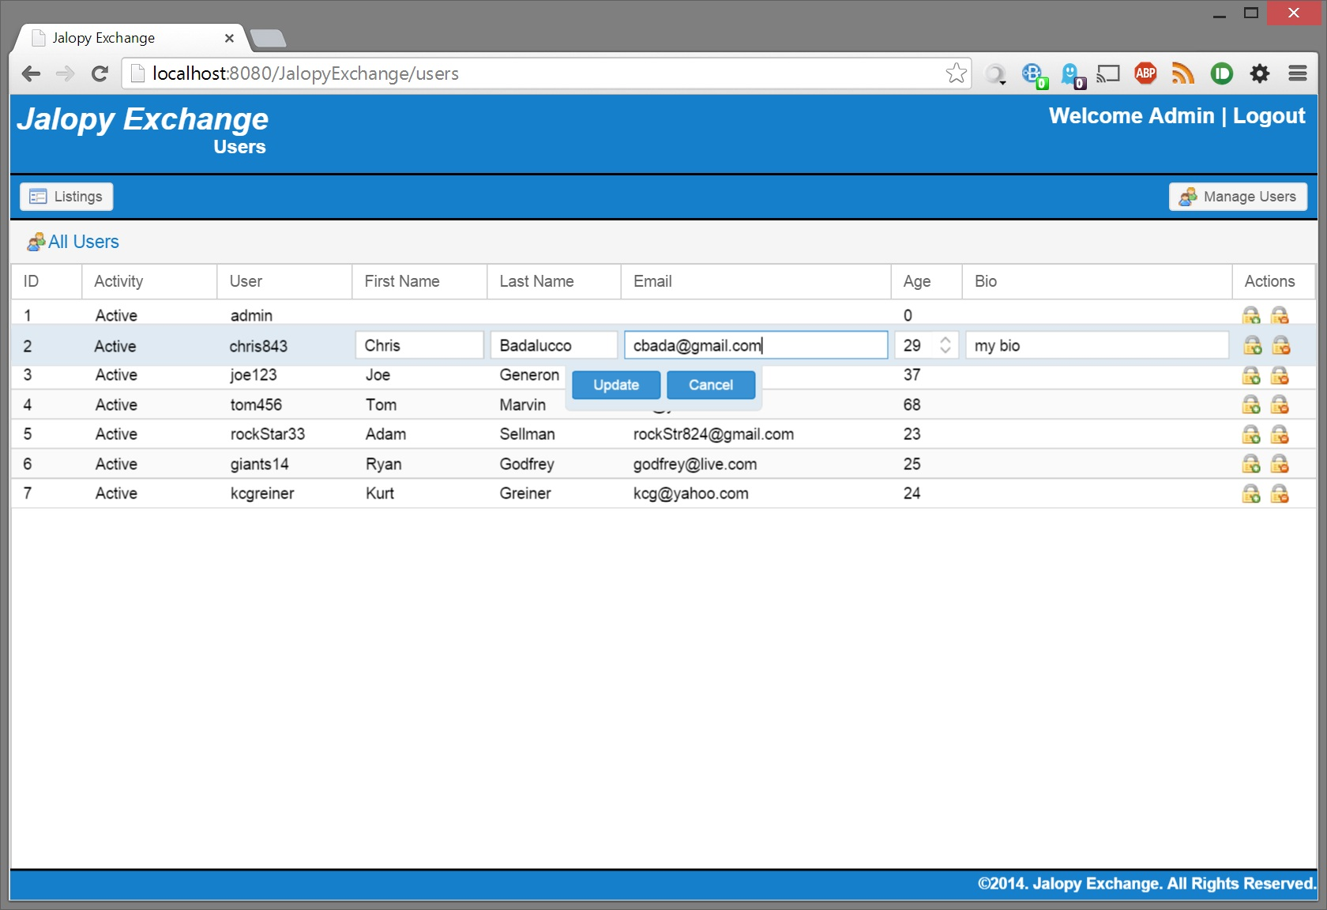

Enforce valid input (e.g. email, min/max age)

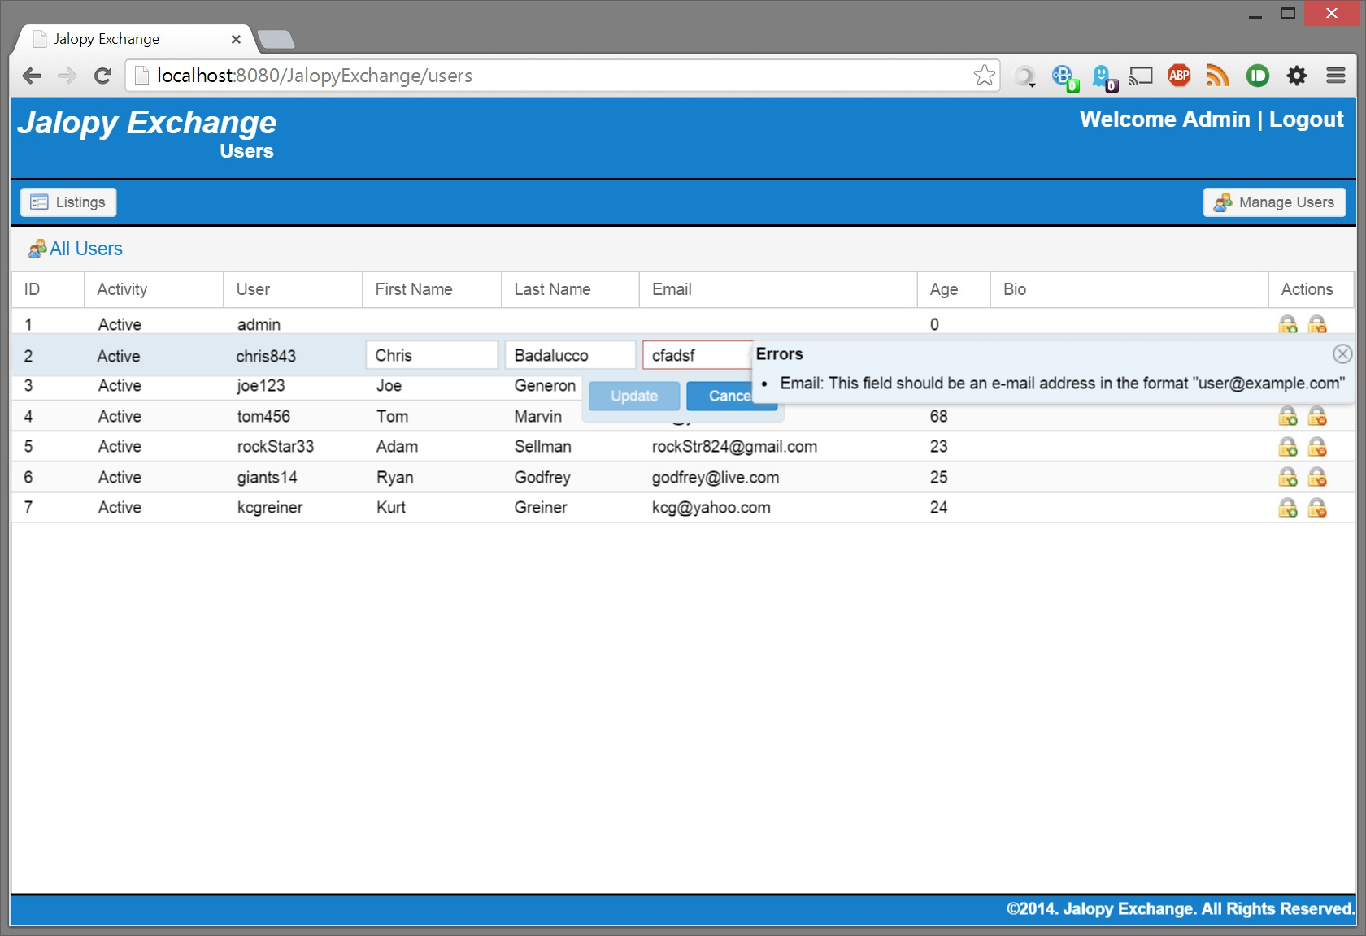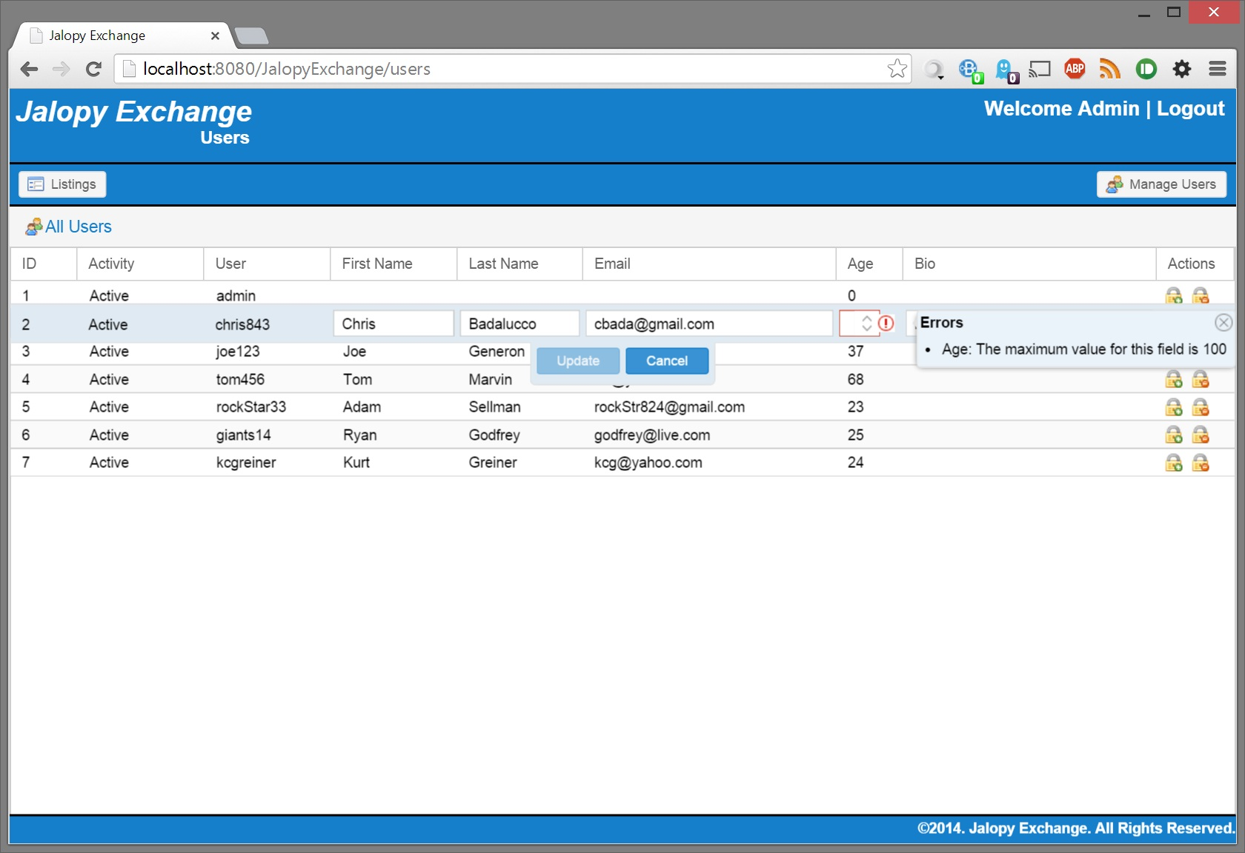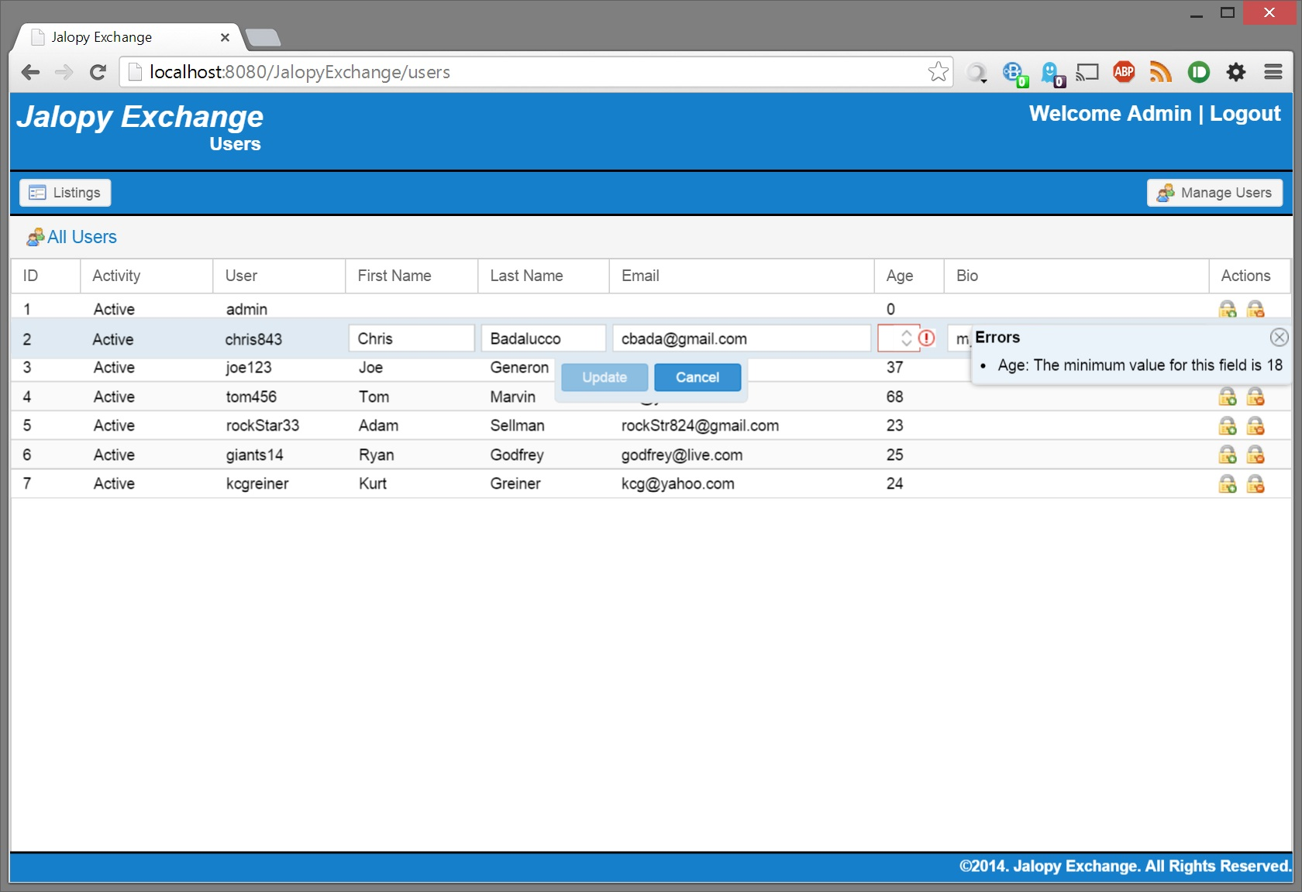

Confirm changes have been saved

